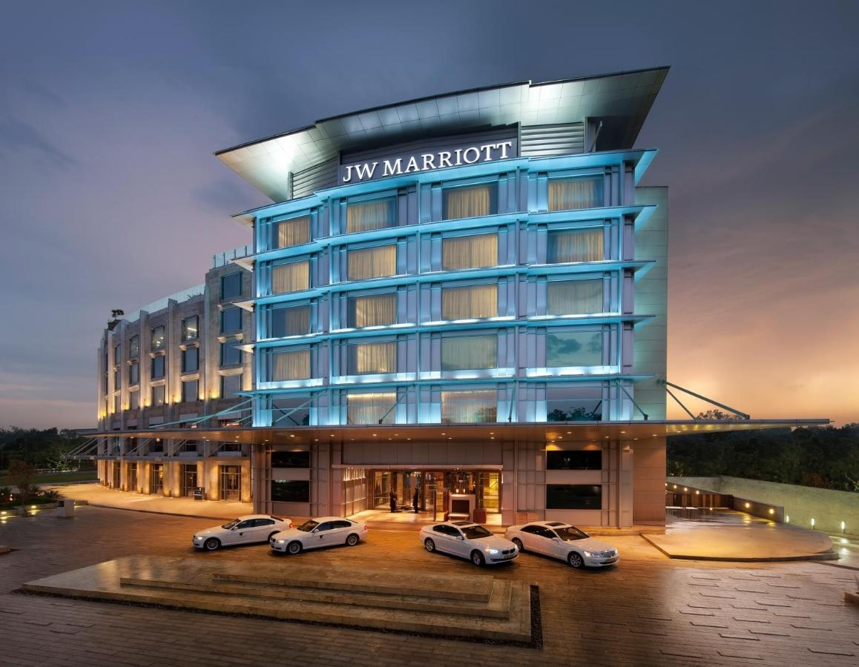

LUXURY MARKETING IN HOSPITALITY SECTOR

STUDY ON JW MARRIOTT, INDIA

**REPORT SUBMITTED BY:**

POORNIMA G | RENU SREE P | ROHAN N | RAHBAR ALI

CONTENTS

1. Luxury Hospitality Sector - India
2. Luxury Hospitality - Bangalore
3. Secondary Research
   1. About JW Marriott
   2. STP Of Marriott
   3. 7P’s Of Marriott
   4. 8P’s of Luxury Marketing for Marriott
4. Primary Research
   1. Interview with JW Marriott Director-Sales
   2. Images from site visit
   3. Anti-laws of Marketing adopted by JW Marriott
   4. Customer interviews
5. Conclusion
6. References
7. **Luxury hospitality in India**

**India Luxury Hotel Market** was worth US$ 23.69 Bn. in 2020 and total revenue is expected to grow at a rate of 8.92 % CAGR from 2021 to 2027, reaching almost US$ 46.93 Bn. in 2027.

The luxury hotel sector, which presently accounts for about **11 percent of India’s entire quality hotel supply**, has recovered developer attention in recent years owing to its marvellous potential on account of partial supply.

Local hotel brands like **IHCL**, **Oberoi**, & **ITC** usually ruled the luxury segment in the country. But, in current years, numerous global hotel chains, counting **Marriott, Accor, Hilton, & Hyatt**, have come into the luxury & ultra-luxury hotel classes in India, making the sector more competitive. As an outcome, luxury belongings donated 11 percent of complete brand signings by key in the year 2020, up from 9 percent in the year 2018.

The luxury sector earlier catered mainly to worldwide tourists & high-income local travelers. But, there has been a change in this trend in new times owing to the developing market dynamics & shifting customer inclinations in the country.

In their mission for distinctive & high-end notable experiences, a growing number of ambitious, affluent, & discerning Indians are now eager to splurge on hotel stays through their holidays. This is particularly obvious in the aftermath of corona virus pandemic, as luxury travel has recovered faster than the other classes, with the ironic opting for local leisure holidays in the absence of world-wide travel.

After a year of WFH & video calls, Indians with high disposable pay are now eager to pamper & overspend on their long-awaited post-pandemic holidays, expecting to make up for the lost time & get away from it all. As an effect, reservations poured at luxury properties – from **palaces** & **beach hotels** to boutique **wildlife cottages** – within driving distance through the nation as soon as the travel restrictions & lockdown were reduced after the 1st & 2nd waves of the corona virus pandemic.

Demand for luxury properties is also being compelled by the ‘big fat Indian wedding’ sector. Numerous couples who wanted destination weddings in photo-perfect foreign places but couldn't go owing to COVID restrictions have curved to Indian luxury hotels & resorts for wedding functions.

The Indian luxury sector has marvellous untapped potential as most of the growth so far has been centered nearby popular destinations like Goa & Rajasthan. However, proprietors are now estimating some under-explored destinations with the Andaman’s, Lakshadweep, & northeast India for luxury hotel & resort growths in the same way as Maldives & Bali. In adding, the luxury resorts sector has efficiently exploited on the growing demand for wellness tourism in the nation in recent years.

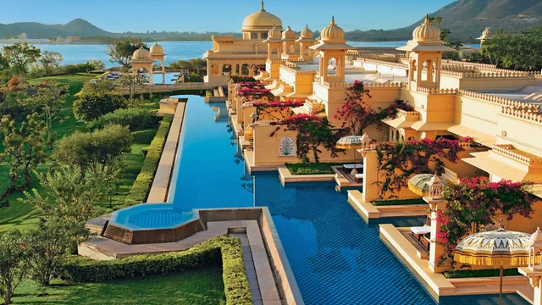

## **India Luxury Hotel Market key players**

* + 1. Hyatt Hotels Corporation
    2. InterContinental Hotel Groups
    3. Marriott International
    4. Radisson Blue Hotels
    5. Shangri La Hotels & Resorts
    6. Taj Hotels Resorts & Places
    7. The Lalit Hotels
    8. The Leela Palace
    9. The Oberoi Group
    10. The Park Hotels
    11. Bharat Hotels Limited
    12. Hotel Leela venture Limited
    13. ITC Hotels Limited
    14. The Indian Hotels Company Limited
    15. Sarovar Hotels Private Limited
    16. Lemon Tree Hotel
    17. Treebo

In 2020, South region dominated the India Luxury Hotel Market.

Among the many hotel chains, the Indian Hotels Company Limited (**IHCL**), the **Oberoi** Group of Hotels and **ITC Group of Hotels** are some of the oldest and have left an indelible mark on the luxury hospitality sector’s landscape. **IHCL, the first hotel group in the country, was the parent company behind the Taj Mahal Palace Hotel** that opened in 1903 in Mumbai, and 196 other Taj properties across the country and abroad. The said hotel, in fact, played host to several eminent personalities, including former US president Barack Obama and his wife Michelle.

The Oberoi Group operates 31 luxury hotels in the country and abroad while the ITC group has 14 luxury hotels. These companies have offered luxurious and unmatched service that has remained unchanged for decades despite the changing times. These companies have already built a teflon reputation but not far behind are some newer luxury brands that have managed to create a niche for themselves by focusing on experiential living and a non-generic approach to service.

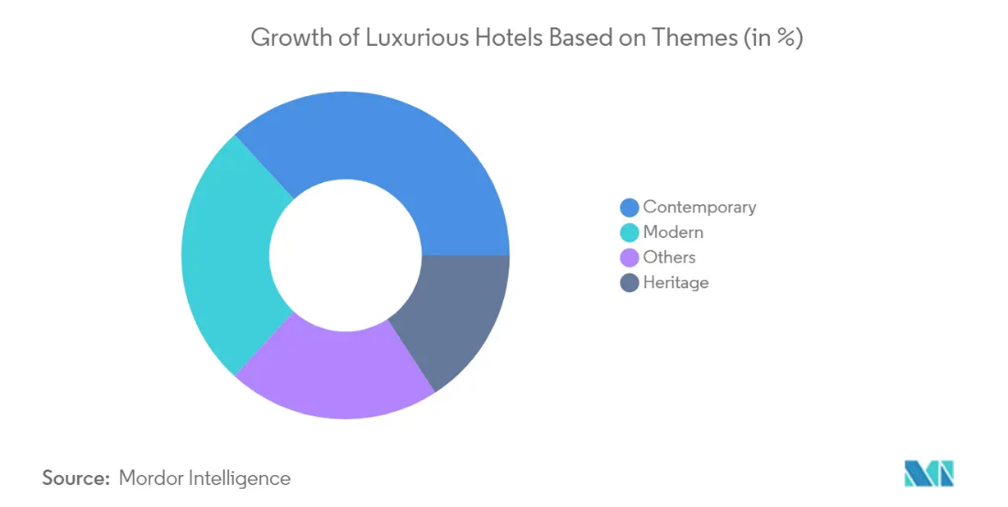

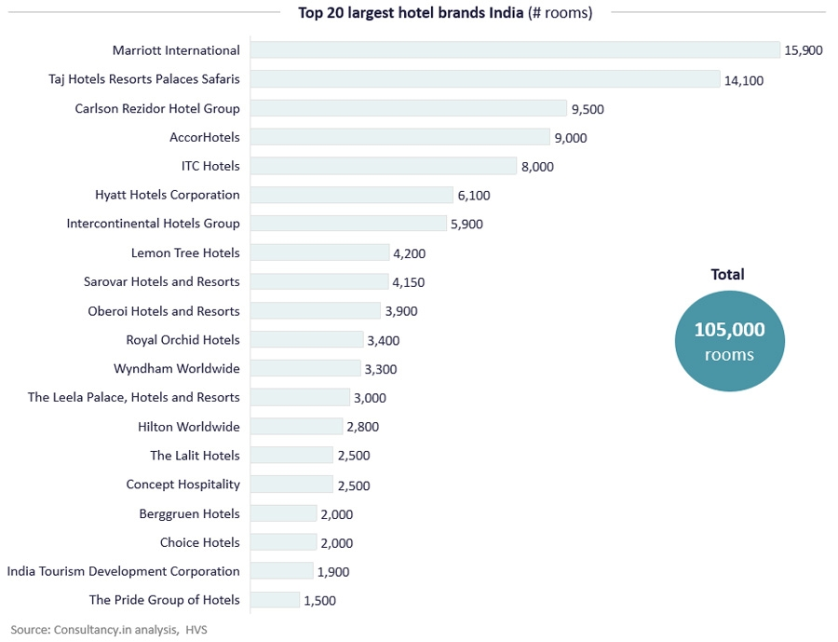

1. **Luxury Hospitality In Bangalore**

Excerpts from <https://bwhotelier.businessworld.in/article/Bangalore-market-is-different-from-anywhere-else-in-the-country-Parul-Thakur-GM-JW-Marriott/05-02-2015-92501/>

According to Parul Thakur, the General Manager of the JW Marriott, Bangalore hotel market is very different from Mumbai or Delhi. The corporate side of the business is predominantly from the IT (Information Technology) sector. The market here is more GDS (Global Distribution System) driven than anywhere else in the country. While in other markets in India, it’s about getting on to the RFP (Request for Proposal) program and drive your business through relationships you develop with individuals, Bengaluru is predominantly about technology and GDS.

Unlike other Indian markets, where there is a one definite leader in a set of four or five top luxury hotels, in Bengaluru, everyone commands a very **different segment**, and are all **very niche**.

The **Leela has a palatial feel**, the **Taj has huge grounds** **and the heritage tag**, the **Oberoi is culturally strong,** and **ITC is known for its LEEDS** certification. JW **Marriott is known for its consistency**, ’Guests know what to expect from our brand.’

One of the challenges of operating in Bangalore was the almost negligible amount of MICE (meetings, incentives, conferencing and exhibitions) happening in the city. In most markets if corporate does well from Monday to Thursday, with every hotel selling out. It is the weekends which makes the difference.

Bangalore has always been a market with **high demand and low supply**, it’s only in the last couple of years that this has changed, especially last year which saw a huge increase in room supply, with the JW Marriott and the Ritz Carlton both opening in the city.

The other huge challenge for hotels in the city is their food and beverage. Every nook and corner of Bengaluru has a great restaurant. That makes it all the more difficult for us to sustain the f and b in the hotel.

Any five-star hotel in Bengaluru has a 40 to 45 per cent occupancy. JW Marriott’s target was to achieve 70 to 75 per cent occupancy in food and beverage.

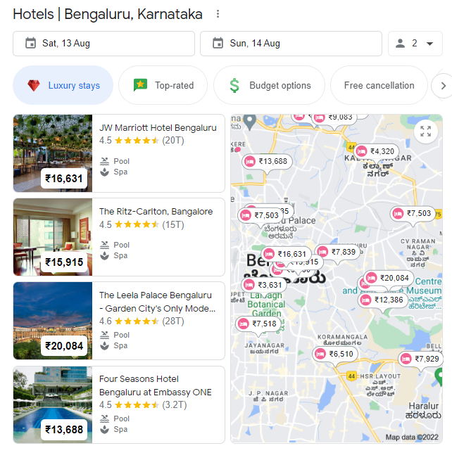

**Best luxury hotels in Bengaluru**

Courtesy: <https://luxuryhotel.guru/bangalore-city/>

## Four Seasons Hotel Bengaluru at Embassy ONE

## The Leela Palace Bengaluru

## The Oberoi Bengaluru

## The Ritz – Carlton

## Shangri-La Bengaluru

## The Leela Bhartiya City Bengaluru

## Aloft Bengaluru Cessna Business Park

## ITC Gardenia

## Renaissance Bengaluru Race Course Hotel

## Sheraton Grand Bangalore Hotel at Brigade Gateway

## Hilton Bengaluru Embassy Manyata Business Park

## Sheraton Grand Bengaluru Whitefield Hotel & Convention Center

## JW Marriott Hotel Bengaluru Prestige Golfshire Resort & Spa

## ITC Windsor

## Grand Mercure Bangalore - An Accor Brand

## Welcomhotel by ITC Hotels

## Davanam Sarovar Portico Suites

## Novotel Bengaluru Outer Ring Road

## Regenta INN Grand Koramangala by Royal Orchid Hotels

## Hotel Royal Orchid Bangalore

## Taj West End

## Oakwood Premier Prestige Bangalore

## The Oterra

## The Den

## The Zuri Whitefield Bangalore

The Leela Palace, Bengaluru

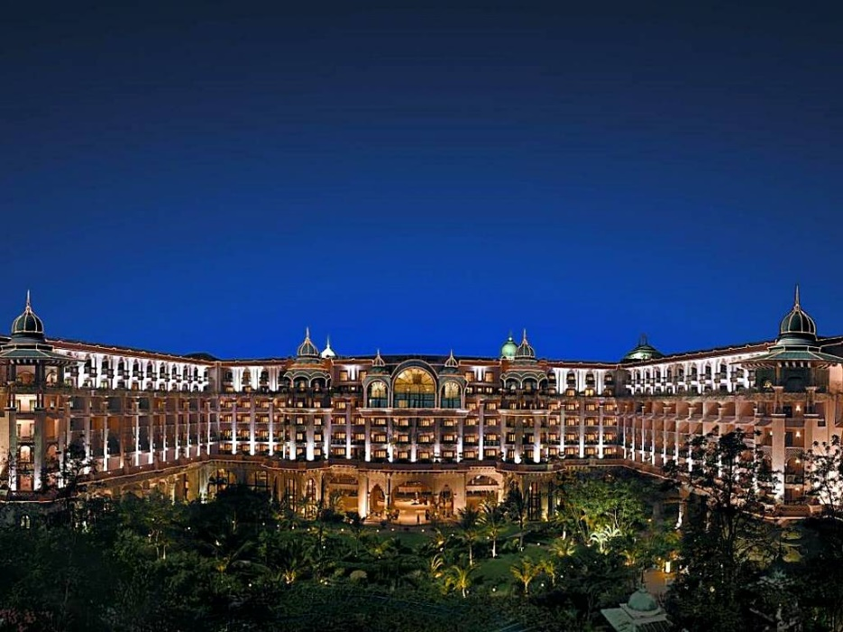

ITC Gardenia, Bengaluru

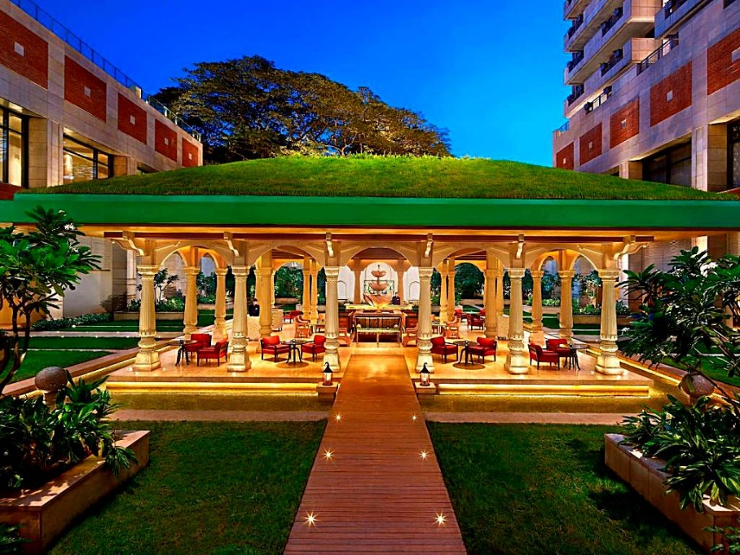

1. **Secondary Research**
2. **About JW Marriott**

JW Marriott Hotel Bengaluru is in the heart of Bangalore, India, just steps from the green gardens of Cubbon Park and only moments from UB City, Koramangala and Mahatma Gandhi (MG) Road, a quiet luxury and exceptional city center from which one can explore Bangalore's top attractions. The hotel has modern venues with flexible floor plans and state-of-the-art audiovisual technology, well-equipped fitness center, a scenic outdoor pool, a tranquil spa and several on-site restaurants, spacious hotel rooms and suites with stylish décor, plush bedding, marble bathrooms and private balconies.

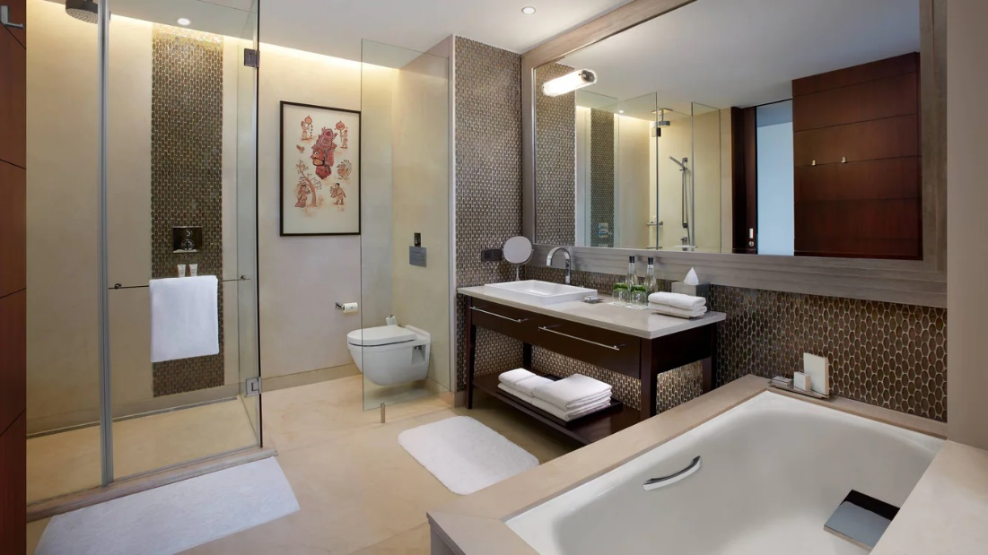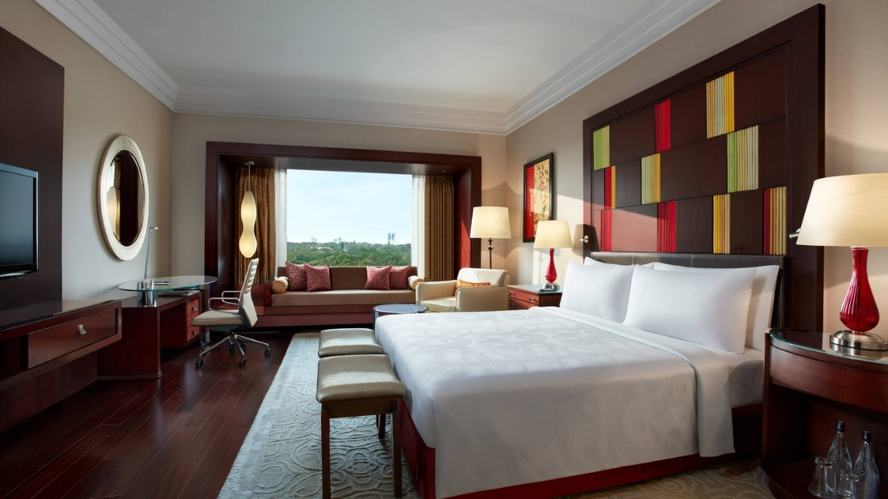

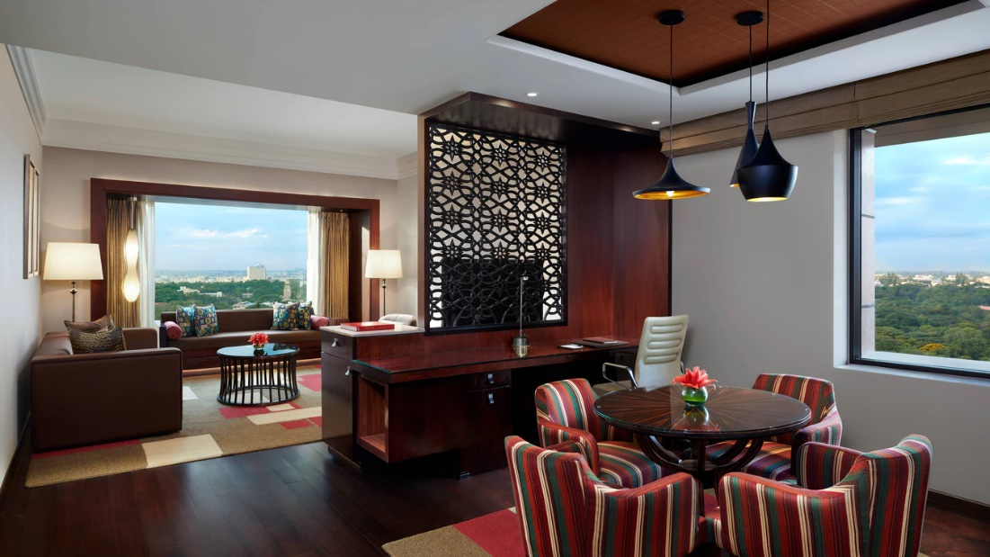

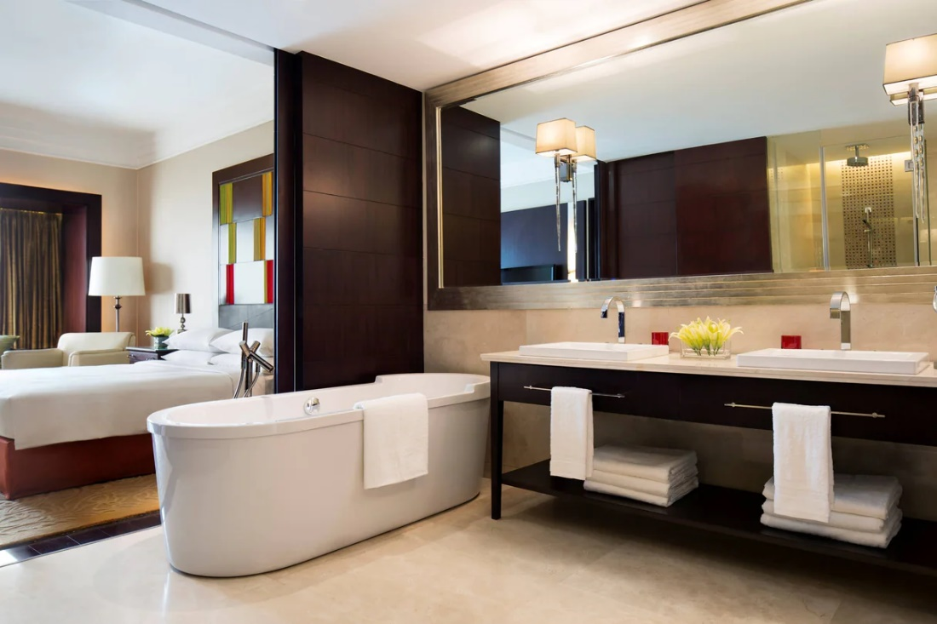

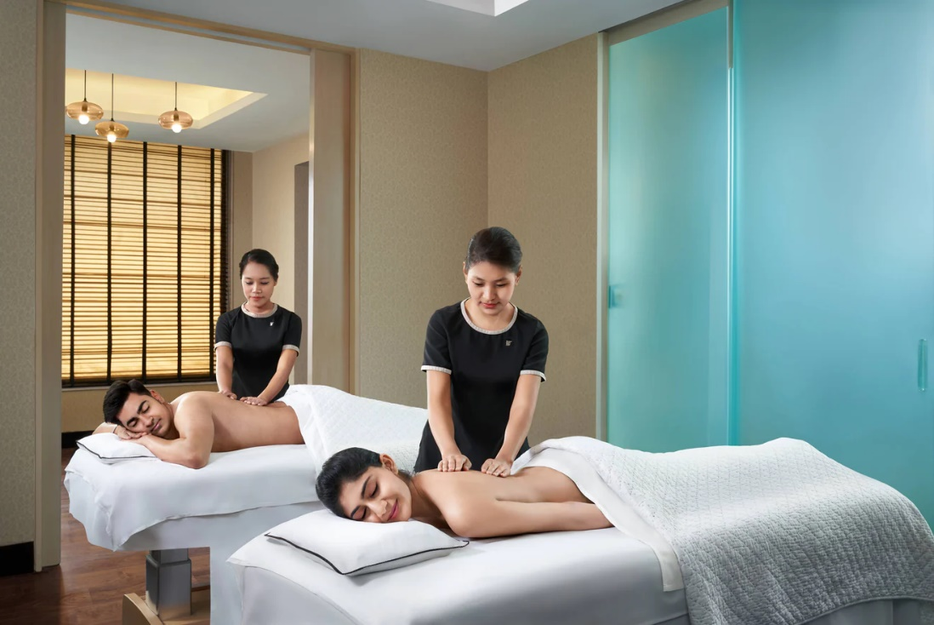

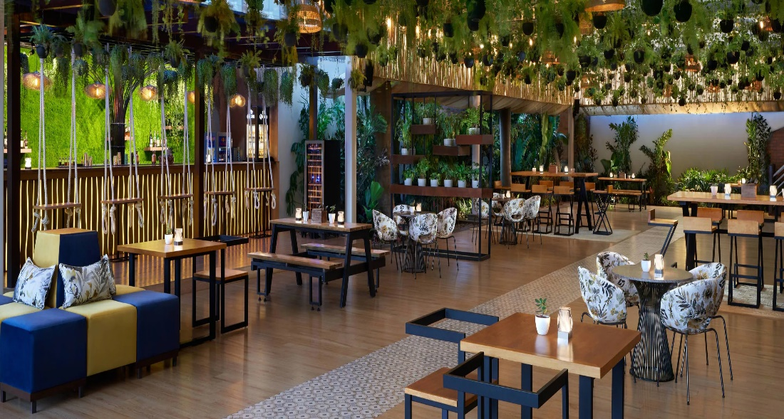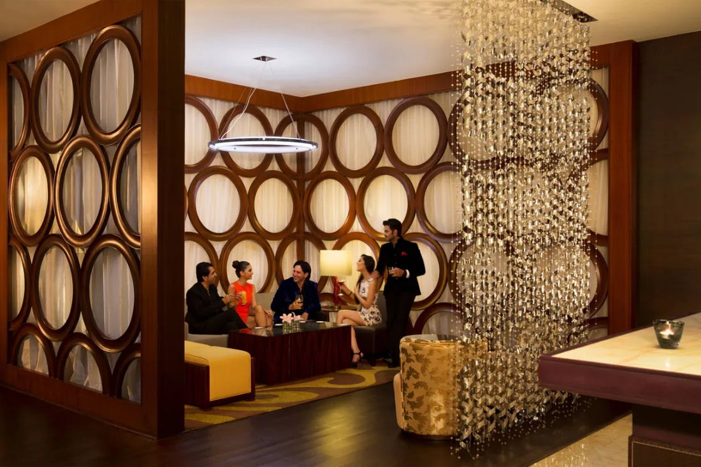

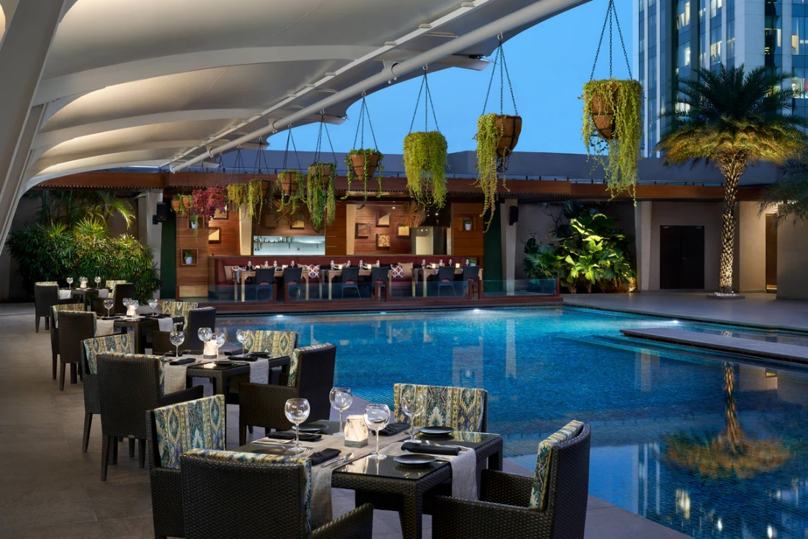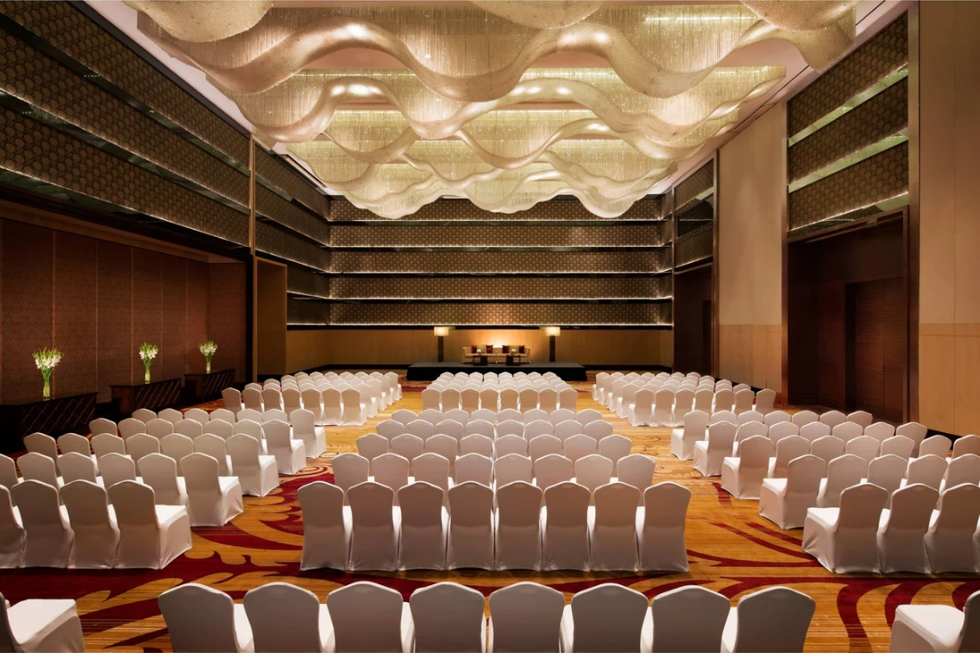

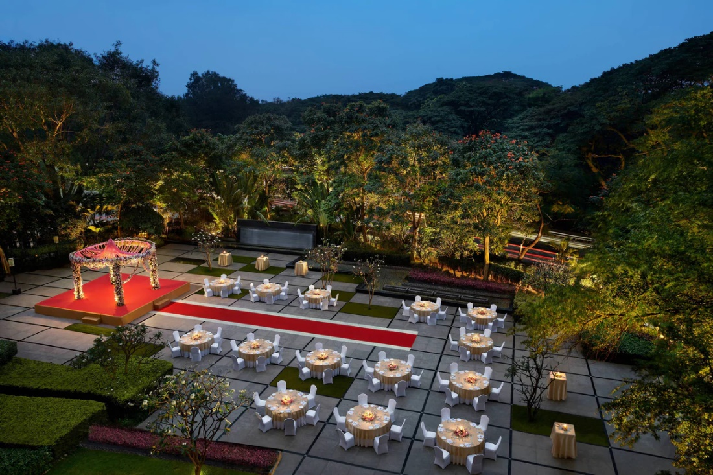

**b) STP of Mariott**

**Segmentation:**

## **Segmentation According to Status**

* Marriott Hotels & Resorts can be discussed in relation to four segments such as luxury hotels, upper upscale hotels, upscale hotels, and upper middle-scale hotels.
* According to this classification, 143 hotels belonging to the brands Ritz-Carlton, JW Marriott, and *Bulgari Hotels* & Resorts are luxury hotels.
* 776 hotels belonging to such brands as Marriott, Renaissance, Autograph Collection, and Marriott Vacation Club are upper upscale hotels.
* More than 1,900 hotels belonging to Courtyard, Residence Inn, and AC Hotels are upscale hotels.
* Finally, 894 hotels of Fairfield Inn and TownePlace Suites can be discussed as upper middle-scale hotels.
* Managers of Marriott also propose alternative market segmentation, determining the following categories:

1. Luxury (Ritz-Carlton, JW Marriott, *Bulgari Hotels* & Resorts)
2. Lifestyle collection (Edition, Autograph Collection, Renaissance, AC Hotels)
3. Signature (Marriott)
4. Select service (Courtyard, Fairfield Inn)
5. Extended stay (Residence Inn, TownePlace Suites) and
6. Destination entertainment (Gaylord Hotels).

## **Geographic Segmentation**

* Marriot addresses the necessity of geographic segmentation while opening hotels representing different brands in various world regions and cities because Marriot hotels operate in 72 countries.
* Thus, for example, luxury hotels like the Ritz-Carlton and JW Marriott are usually located in cities that are characterized by high tourist rates and high levels of household income.

**Psychographic Segementation**

If the customer expects to stay in the hotel with the exceptional services, it is important to refer to such brands as JW Marriott, Ritz-Carlton, and Bulgari Hotels & Resorts (Garrido 2012). If customers plan to organise special occasions like weddings or important business meetings, it is also expected that they visit the hotels of the luxury category because of the highest level of comfort proposed for the clients.

Lifestyle collection of hotels aims to address the specific customers’ interests and needs. Edition, Autograph Collection, Renaissance, and AC Hotels are unique in terms of their design and proposed services. Therefore, these hotels usually attract businessmen, single travellers, and married couples. The unique services are proposed to customers in such hotels as Courtyard and Fairfield Inn in spite of the appropriate prices.

## **Behavioural Segmentation**

* The behavioural segmentation is usually realized with references to such factors as the proposed promotions, rewards, and benefits along with the loyalty programmes and proposed schemes of services provision.
* Marriott pays much attention to focusing on exceptional services, unique designs, and remarkable experiences.
* Marriott hotels proposed discount and loyalty programmes for different categories of customers in order to address their needs and improve their attitude towards the services provided.
* Much attention is paid to attracting those customers who represent the group of businessmen staying in the hotel during a long period of time. These customers also receive special offers according to their loyalty programme.

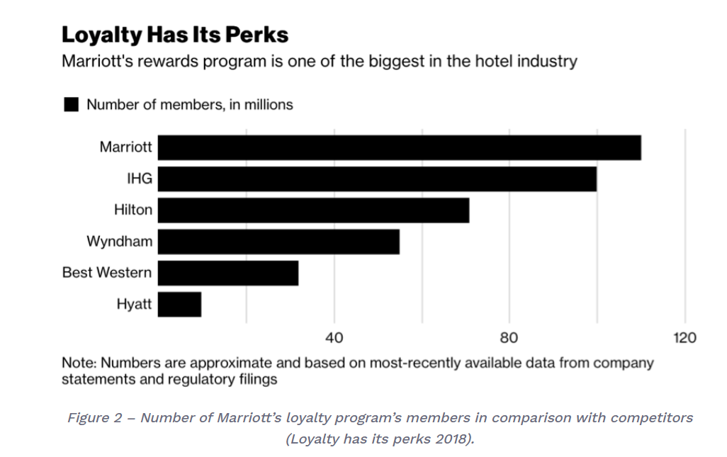

* Customers using the hotel's services for organizing different occasions are also offered a range of rewards in order to improve their reputation and attract other potential customers.

## **Target Market of Marriott International**

* A Target Market refers to a group of individuals identified as being likely customers of a business. The target market usually includes customers who share similar demographic traits.
* This is how Mariott International segments its target market:

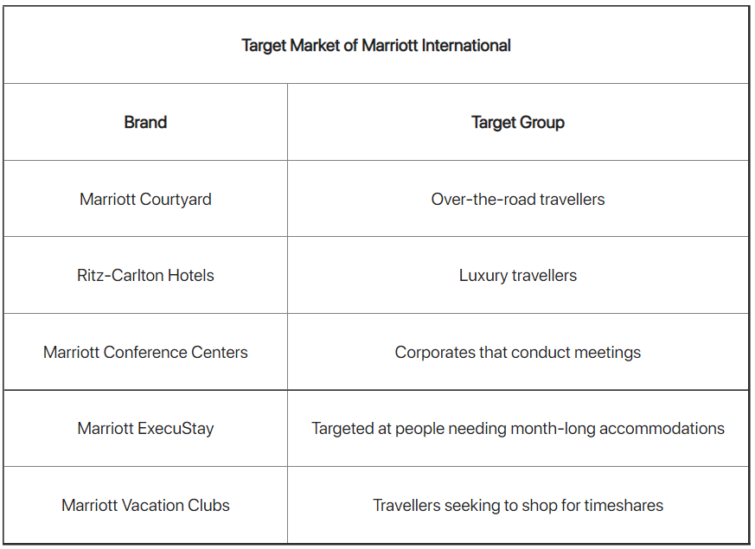

* The JW Marriot, created by Marriott international as a luxury brand, is meant to focus on customers who are seeking a quiet and opulent atmosphere during their accommodation.
* Marriott International has successfully built-up different target markets within its industry by specifically targeting the requirements of its customers.
* Therefore, their customers are mostly individualistic, sophisticated, and self-defined travellers who are willing to spend extra money on their accommodation as well as people travelling on a business trip.

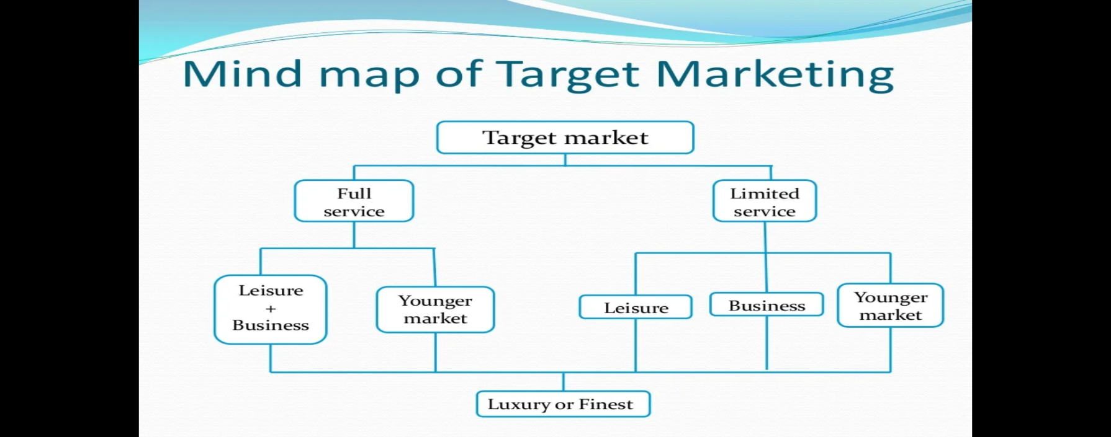

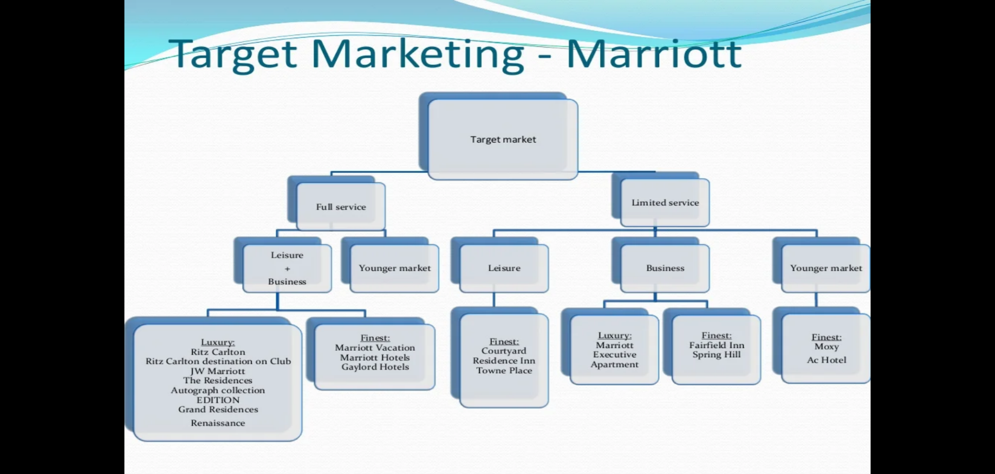

**Positioning:**

## **Marriott Mission Statement**

To enhance the lives of our customers by creating and enabling unsurpassed vacation and leisure experiences.

## **Marriott Vision Statement**

To become the premiere provider and facilitator of leisure & vacation experiences in the world.

From the mission and vision statements, it is understood that Marriott wants to position themselves as provider of luxury services for any occasion such as business meetings, vacations, leisure, weddings, parties etc.

**c) 7P’s of Marriott:**

1. **Product:**

* Marriott International is one of the leading names in the hotel industry that provides lodging services worldwide in various segments.
* Apart from many properties that offer luxury lodging services, Marriott also offers lodging services under the premium, select and timeshare categories.
* Of the thirty brands in its portfolio, seven offer luxury lodging services. Ten of its brands offer lodging services in the premium category and 11 in the select category. Apart from that, Marriott offers residences and timeshare properties.
* The luxury brands in the portfolio of Marriott International Inc include J W Marriott, The Ritz Carlton, W Hotels, The Luxury Collection, St Regis, EDITION, and Bulgari.
* The premium brands in the portfolio of Marriott International include Marriott Hotels, Sheraton, Westin, Renaissance Hotels, Le Meridien, Autograph collection hotels, Delta Hotels, Gaylord Hotels, Marriott Executive Apartments, and Tribute Portfolio.
* Brands under the Select range offer smart and easy amenities and services. The longer stay brands under the Select range offer amenities that reflect the comforts of home like stay. The classic Select Hotel brands of Marriott include Courtyard, Residence Inn, Fairfield by Marriott, SpringHill Suites, Four Points, TownePlace Suites, and Protea Hotels. The Distinctive Select Hotel brands of Marriott include Aloft, AC Hotels by Marriott, Elements, and Moxy. The company also acquired Starwood Hotels and Resorts in 2016.

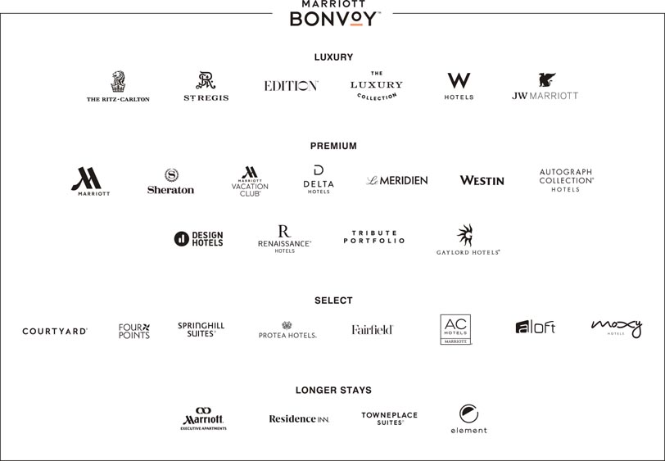

1. **Price:**

* Marriott International is one of the few organizations that has been successful in maintaining pricing power despite significant competitive price discounting, volume shrinkage, and increased room supply.
* In terms of pricing, Marriott International’s price varies with different hotels, customers, and locations. The prime motive of the company is to deliver a top-notch experience that exceeds customer satisfaction for the price they pay.
* It has largely succeeded because their different hotel brands have been able to maintain differentiated value propositions in terms of their brand promise and brand appeal.

1. **Place:**

* Marriott International is well-known and is one of the biggest hotel chain companies in the world regarding the number of hotels they manage and operate both in different parts of the world and in the United States.
* Choosing the ideal place and distribution strategy has played a vital role for Marriott in its journey over the years. Since its foundation, it has established itself in more than 131 countries and the placement of its hotels are mainly centered in and around major cities and towns of a country.

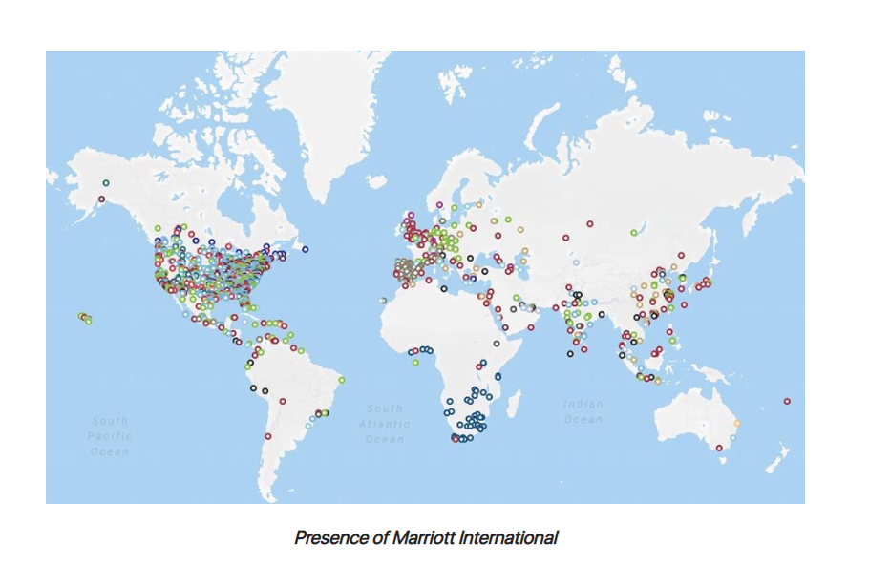

* Being location specific give Marriott an advantage to attract customers like the businesspeople will be acquiring hotel near airport while the travelers will love to do night stay in hotels near highways and tourists in the city near market so that it is easily accessible.

1. **Promotion:**

* For promotions, Marriott mainly relies on digital channels which include its website, app and social media.
* Apart from that, the company has used several rewards programs to maintain customer loyalty.
* The website and app are its main source of promotion from which visitors can book rooms and learn about the latest deals.
* Its Marriott Bonvoy Travel program has around 3.7 million followers on Facebook. It is a free program offered by Marriott to enhance its visitors’ travel experience. This program has several levels including Silver Elite, Gold, Platinum, Titanium and Ambassador Elite. Visitors receive several benefits right for registering with the program like free internet etc. This reward program was introduced in 2019, after combining previous reward programs into one.
* Their campaign on ‘Shaadi by Marriott' got them a huge success in India by promoting the bride’s big day in association with Marriott.

1. **People:**

* Marriott distinguishes the importance of serving its guests, which is the main people strategy of the brand.
* They train their staff in minute details and give them authority in case of any service failure. They focus on training the staff consistently so that they are highly motivated to deliver outstanding services which exceeds the expectations of customers.
* Marriott has continued to focus on improving the level of service quality and convenience offered to Marriott visitors.

1. **Process:**

* There are 22 reservation centers run by Marriott, eight of which are in the US.
* In recent years, the company has increased its investment in digital technology to offer extra convenience to its customers in terms of check in, stay and check out. The app allows visitors to manage their stay with higher efficiency.
* The Marriott Bonvoy app allows its users excellent control and convenience where visitors can order amenities and manage their stay without worrying about anything.
* Marriott has numerous business processes in place to certify quality customer services, efficient bookings and a comfortable stay for customers. Marriott works in a transparent manner where its guests can easily operate and use online booking websites to book the room. It follows check-in from 10.00 and check-out at 12.00 pm policy.

1. **Physical Evidence:**

* The physical evidence part of the marketing mix for hospitality services mainly includes the tangible aspects of the experience that include the properties and amenities mainly.
* Marriott uses branded amenities to make their visitors’ stay memorable and outstanding as well as for branding.
* The Marriott Bonvoy app allows for mobile check-in and order amenities like comb or toothpaste. Moreover, the visitors can use the app to check out previous transactions, folio etc.

**d) 8P’s of luxury marketing for Marriott:**

1. **Performance:**

Marriott stands as a symbol of luxury and heritage.

1. **Provenanace:**

People choose Marriott not only for its services and customer satisfaction, but they are also influenced by its rich heritage, luxury and brand image associated with their hotels.

1. **Paucity:**

Marriott creates a sense of paucity by offering services which are scarce such as being pet friendly i.e., allowing pets to be in rooms with customers.

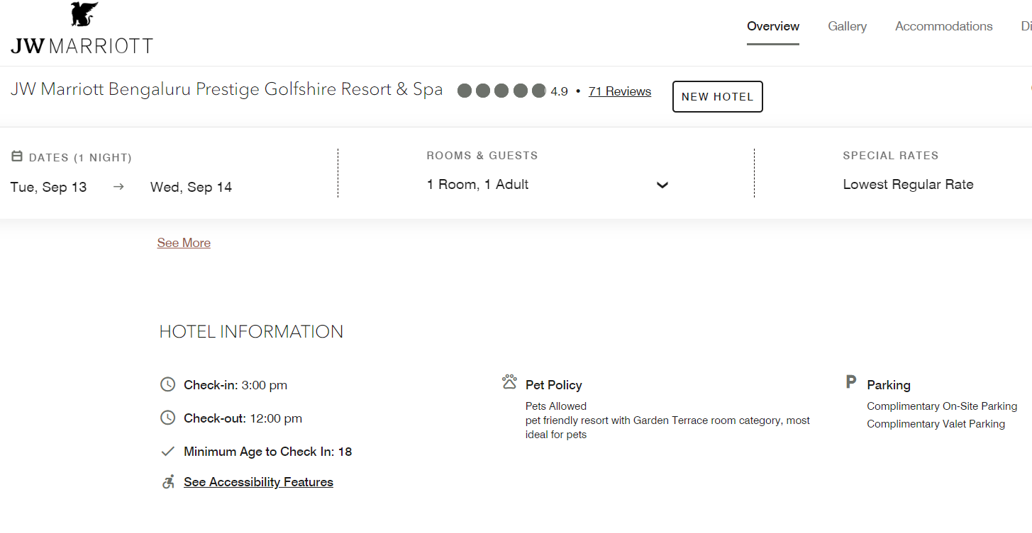

1. **Persona:**

Mariott has an app called Marriott Bonvoy to strengthen brand association by creating a sense of personalization in terms of booking and provides loyalty program through it.

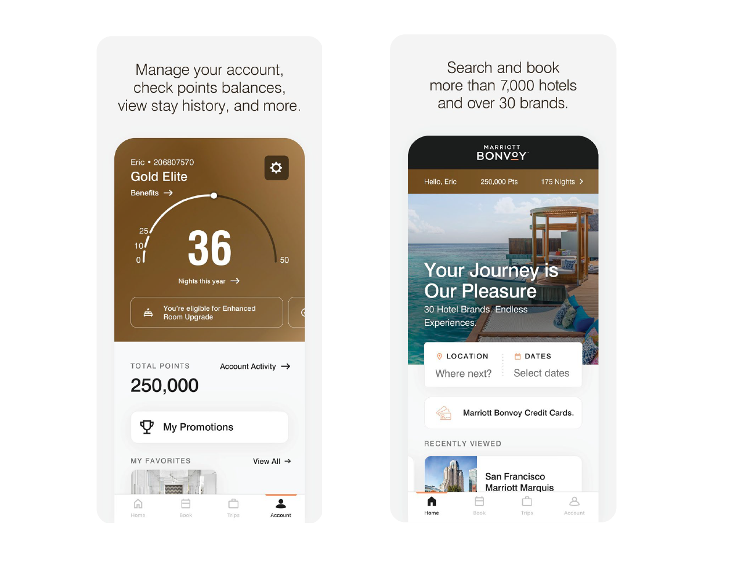

1. **Personage:**

In 2017, JW Marriott Hotels & Resorts announced its partnership with **Nora Tobin**, the health and wellness leader as the brand's Wellness Ambassador.

In February 2022, Mariott appointed [Kareena Kapoor Khan](https://mobile.twitter.com/hashtag/KareenaKapoorKhan?src=hashtag_click) as the Well-Being Ambassador for their Westin hotels in India.

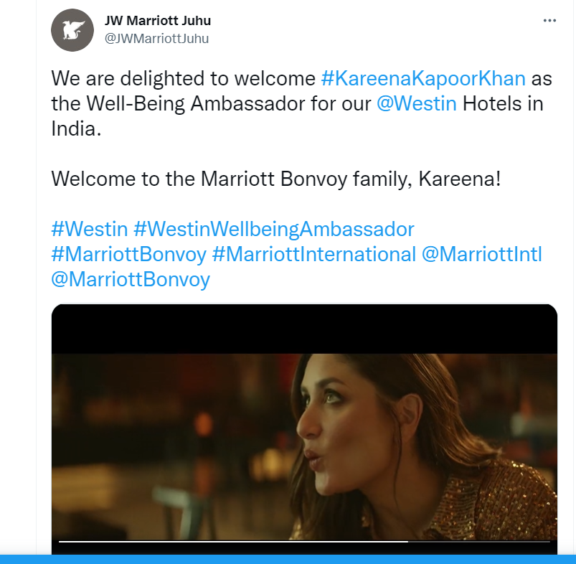

1. **Position:**

Mariott has hotels not only for business purposes but also at remote and peaceful locations for tourists or for enjoying time as leisure. It also has hotels nearer to airports.

1. **Public Relations:**

Mariott uses a strong social media presence for maintaining public relations. For example, to raise awareness around JW Marriott Nashville’s soft and grand openings, Magrino’s digital team created an elevated social media presence that reflected the stunning architecture of the brand-new hotel along with a clear and modern voice.

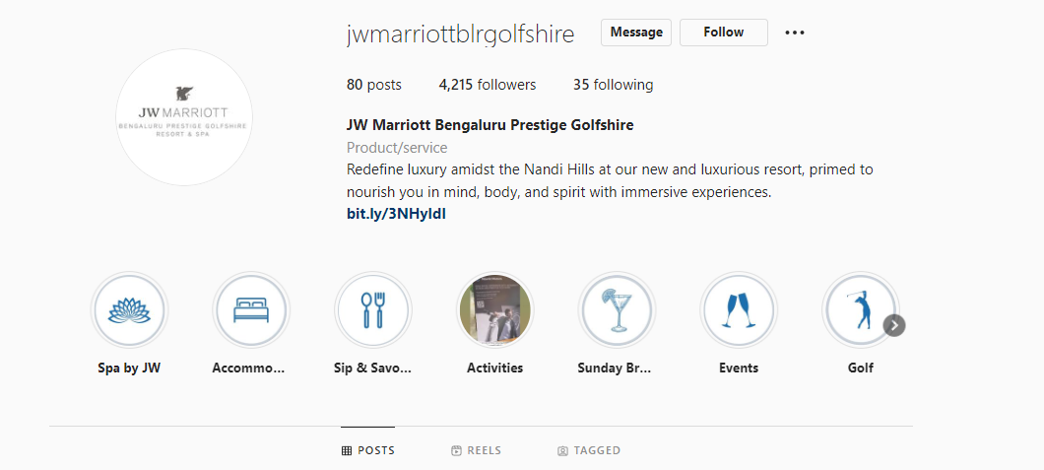

1. **Pricing:**

JW Marriott does not compromise with its prices. In contrast, it serves customer expectations in such a way that the customers are willing to pay any premium price for staying in them.

1. **Primary Research**

**a)**  **Interview with Ms. Pearl Kala (JW Marriott Director-** **Sales, Bangalore)**

1. **What is the working model of JW Marriott?**

**Pearl:** JW Marriott is part of Marriott Consortium. The working model of all Marriott Hotels are the same. All the hotels & resorts are partnerships with the builder. Asset is owned by the builder. Marriott will manage or franchise the properties.

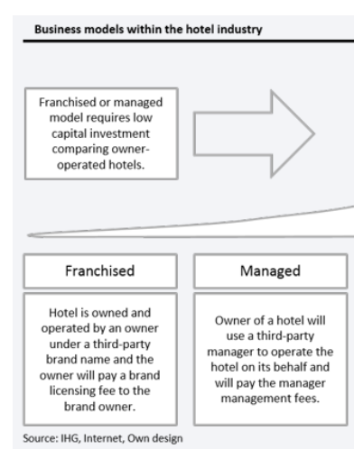

Revenues are earned through managing or franchising properties in the form of Base management fee, franchise fee, licensing fee etc.

**2.** **What are the services offered by JW Marriott Prestige Golfshire?**

**Pearl:** Apart from lodging, we offer Restaurant service, Housekeeping services, Spa, Fitness Center, Outdoor Pool, Hot tub, Meeting Rooms, Bar, Game room, Kids activity room, bicycle rental, Laundry, Dry Cleaning, Kitchenette, Turndown Service, Wakeup Calls, Room Service, Car Parking.

**3.**  **Are there any signature elements to your offering?**

**Pearl:** There’s no such thing as such. However, we do have certain fixations.

* 1. We ensure that our room sizes are standard ~ minimum of 52 Sqm and all our resort rooms come with Balconies.
  2. We have a pet-friendly policy. Pets are allowed in rooms, except public areas.
  3. We promote ourselves as a wellness brand. We offer vegan cuisine, calorie counts, fitness centers, yoga sessions for guests.
  4. We have created “Secret Spots” all around the facility. These are small spaces tucked away for reading, being there alone, as part of overall wellness.
  5. Major Airliners are our partners and convert points into Airline miles. We have partnerships with luxury cars, EV Charging stations, etc.
  6. Our Bonvoy membership offers many benefits. You can upgrade your membership from Silver Elite to Gold Elite to Platinum Elite, Titanium Elite and Ambassador Elite.

**Silver** Elite: 10 nights per year;

**Gold** Elite: 25 nights per year.

**Platinum** Elite: 50 nights per year

**Titanium** Elite:Stay 75 nights/ yr.

**Ambassador** Elite: Stay 100 nights/ yr. + $20,000 USD spend

**Features and benefits:**

* + 1. Reservation Guarantee
    2. Points bonus
    3. Late Checkout
    4. Welcome amenities – Breakfast,
    5. Club Lounge – Bar
    6. Room upgrade
    7. 5 Suite night awards
    8. 24 hour check-in, check-out
    9. 48 hour booking guarantee
    10. Ambassador service

**4.**  **Who do you consider to be your competitors in Bengaluru?**

**Pearl:** No one really. Our segment and offerings are unique.

Maybe, Four Seasons in Bangalore can be considered as competition.

**5.** **Do you have any corporate partners who book JW Marriott exclusively?**

**Pearl:** No. There’s no such exclusive partnership. There’s no loyalty concept among corporate clients. They mostly deal with more than 1 hotel brand.

However, many corporate brands prefer us for the “Ease of doing business” and book our convention centers frequently because of the Airport vicinity.

We have partnerships with luxury car brands, Charge Zone, Emirates etc.

**6.** **Are there any notable sustainability initiatives/post Covid measures?**

**Pearl:** Yes.

* 1. We have gotten away with plastic water bottles in most of our hotels. We have our own bottling plants and offer water from our plant to the guests.
  2. We stopped using flowers in our lobbies, reception, or dining.
  3. We use succulents and environmentally friendly plants instead.
  4. We stopped offering plastic straws, plastic combs.
  5. We have organic waste converters that convert kitchen waste into manure to use in our gardens.
  6. We also follow No Bin policy in dining areas to minimize waste generation.
  7. All our common areas are enabled with motion sensors
  8. We use solar power from panels installed in terraces.
  9. Installed EV Charging stations

**7.**  **What is JW Marriott’s core values?**

**Pearl:**

* 1. We put people first - If we take care of Associates (Employees), they will take care of Customers.
  2. We Pursue Excellence
  3. We embrace change and innovate
  4. We act with integrity
  5. We work for the bigger good.

**8.**  **How do you promote? Do you have dedicated Marketing team for Promotions?**

**Pearl:** We promote through Billboards, Social Media, TV, Newspapers etc. We also promote through our partners – Mercedes, Porsche and Toyota.

We do not make exceptions for celebrity functions. Our policy is the same for everyone. Some influencers do post their experiences with us. But we do not make paid influencer content.

We have a dedicated Marketing and Communications team to manage all media communications and Social Media promotions.

**9.** **Any initiatives in terms of diversity and inclusion?**

**Pearl:** Yes. Our employees are diverse, and we include all genders, races, ethnicities, differently abled people in our workforce. We do not differentiate between customers. All our customers and visitors are treated the same way.

**10.** **Do you follow specific architecture/ interior design in your hotels? Do you have**  **preferred vendors for interiors and facility management?**

**Pearl:** No. Design is done by Builder’s architect. Interiors are done by the builder. We approve the designs to ensure they are international standards. Other than that, we do not get involved.

All the staff are in Builder’s payroll, except the ones in Management. The housekeeping, reception, security and even the Chefs are all Builder’s staff.

We just manage the facility.

**11.** **What are the future plans of JW Marriot?**

We have several projects in pipeline to add more locations and rooms.

Apart from business locations, we are planning to expand to holiday locations.

**B)**  **Pictures Of Jw Marriott, Prestige Golfshire**

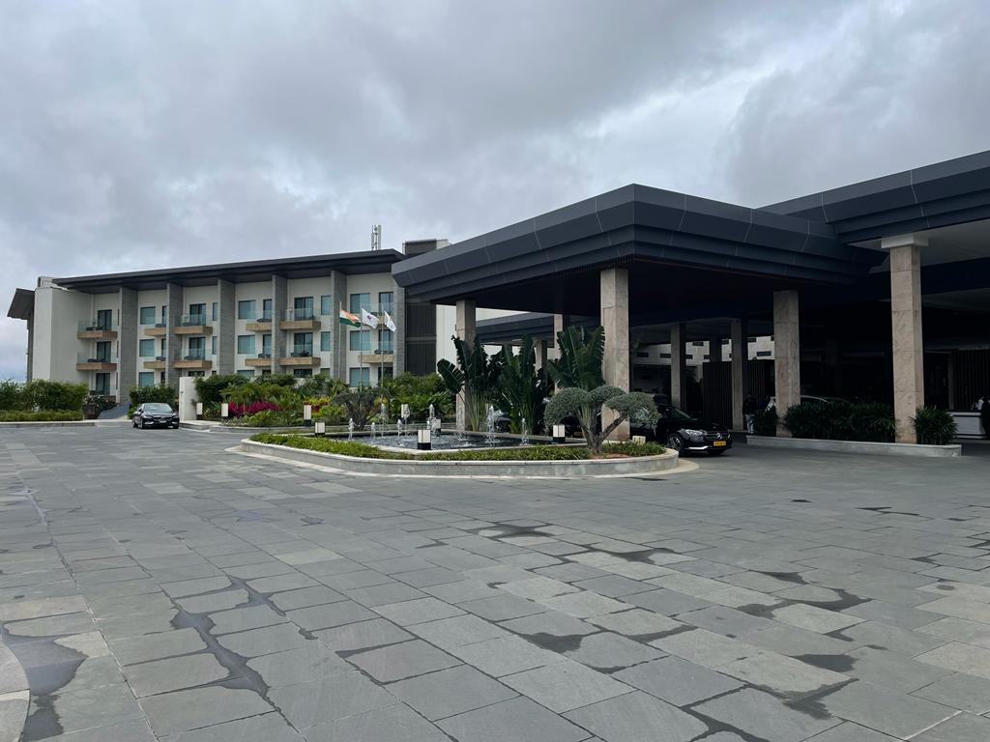

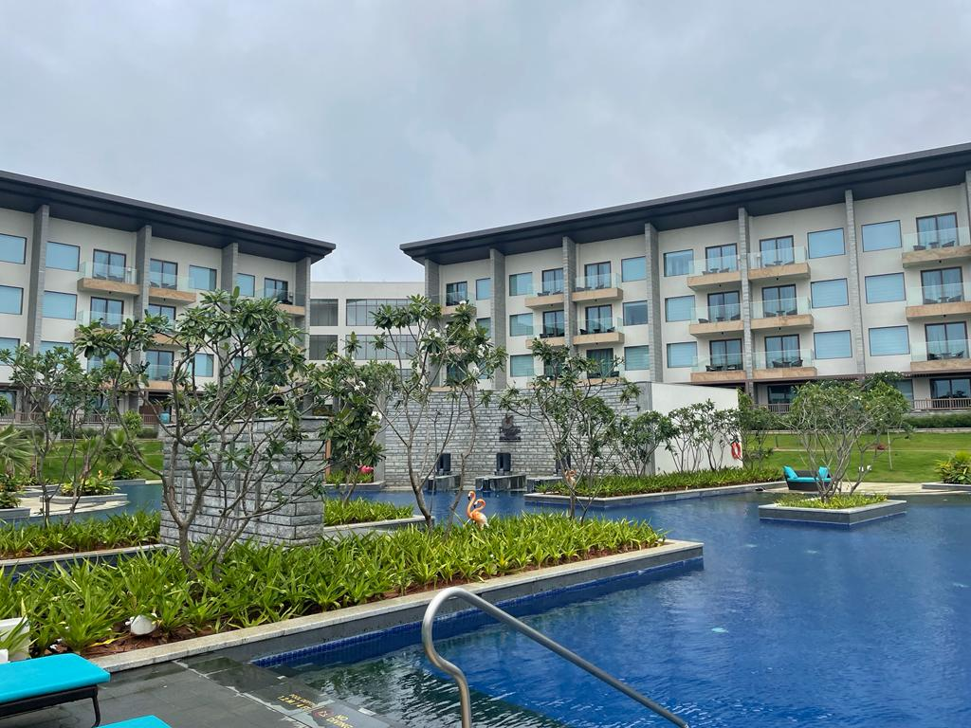

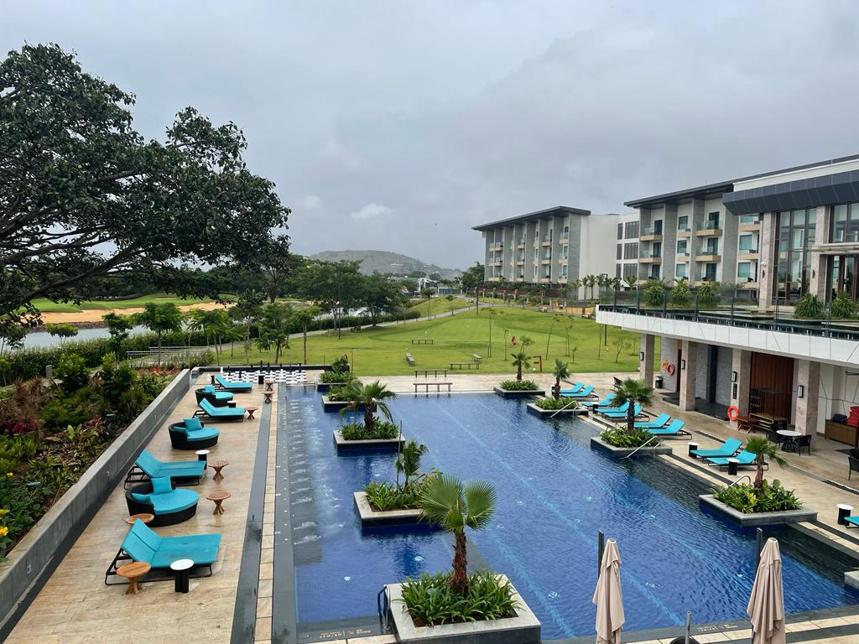

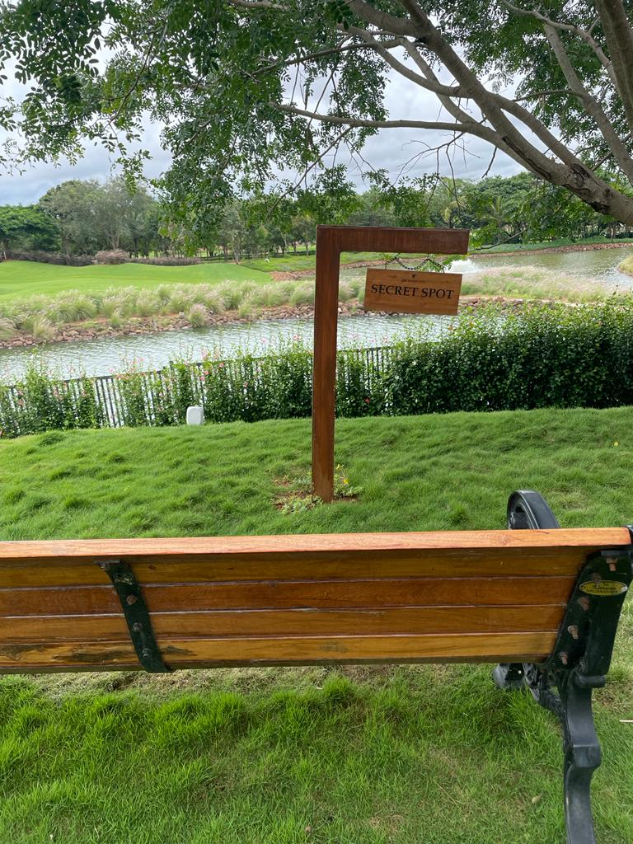

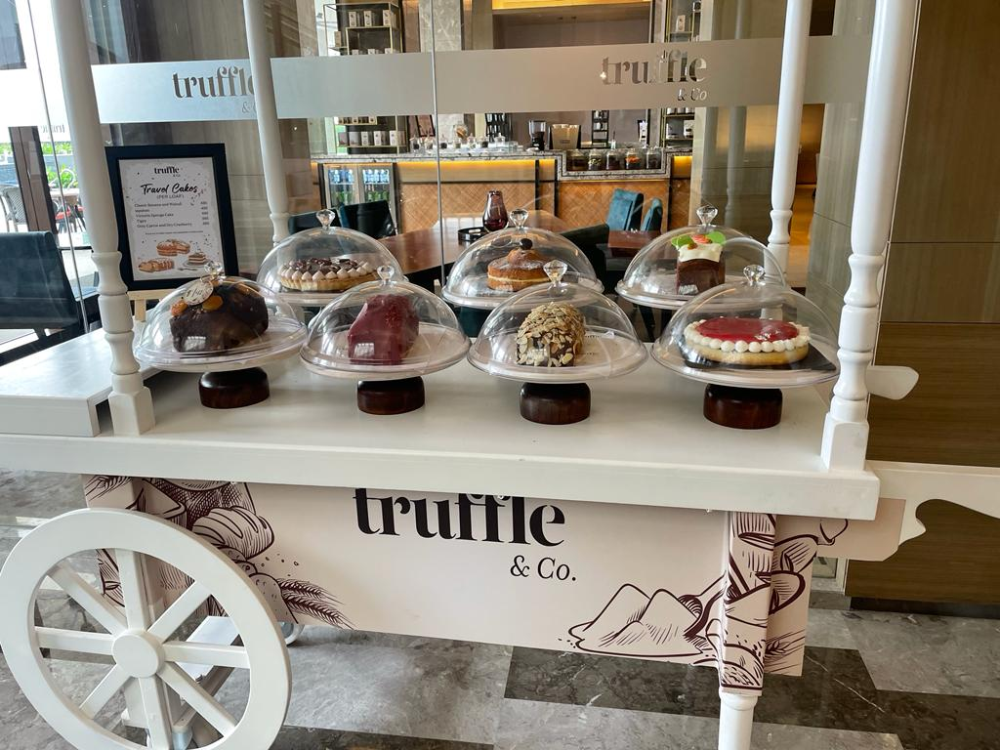

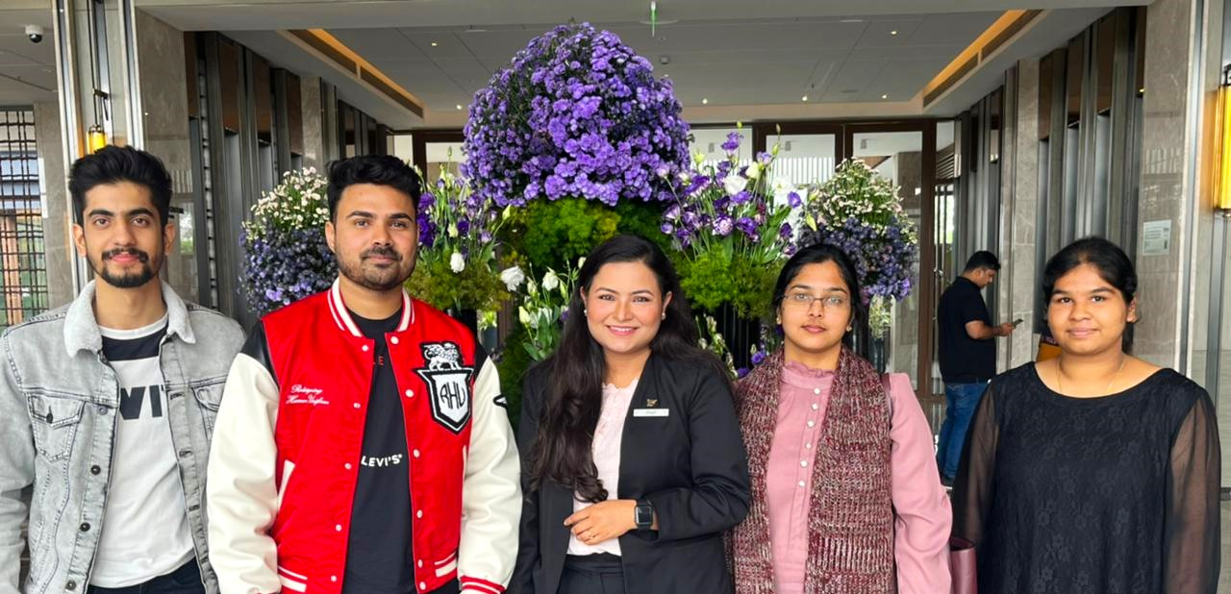

## **c) The 24 anti-laws of marketing followed by JW Marriott**

1. **Forget about positioning; luxury is not comparative**

From Ms. Pearl’s response, it is seen that JW Marriott doesn’t consider anyone as competition.

1. **Does your product have enough flaws to give it soul?**

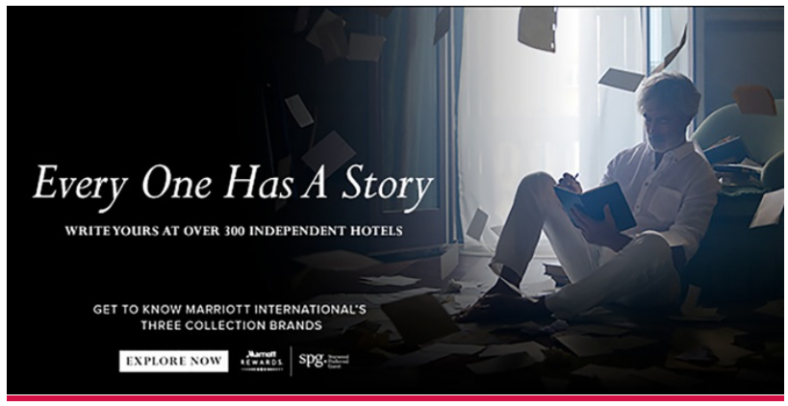The above campaign of Marriott is a message inviting customers who do not travel for mere luxury but to do things they have a passion for.

It creatively reinforces the growing demand among today’s consumers for unique travel experiences.

The campaign visually counts down the captivating experiences and cherished memories that global travellers collect when staying at the company’s independent hotels around the world.

The Luxury Collection, part of the company’s extraordinary portfolio of luxury brands, represents hotels that define the destination and provide a true luxury experience.

Autograph Collection Hotels are hand-selected for their rich design and immersive stories; while Tribute Portfolio brings together characterful hotels with vibrant social scenes that create a sense of belonging for guests and locals.

1. **Dominate the client**
2. **Make it difficult for clients to buy.**
3. **Protect clients from non-clients, the big from the small**

From Ms. Pearl’s response, it is seen that Marriott offers Bonvoy Membership exclusively for Marriott Clients restricting offers and benefits only for member clients.

1. **The role of advertising is not to sell**

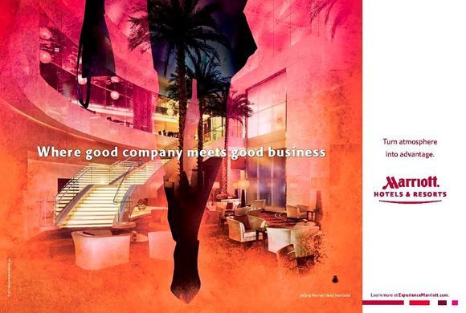

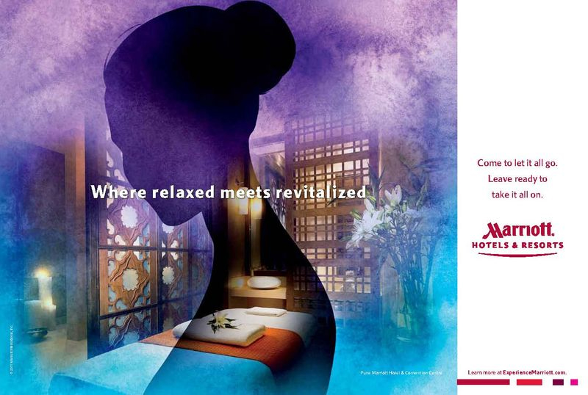

Below Ad on the occasion of the launch of their Jaipur Resort emphasizes the art elements and no mention on pricing of the accommodations.

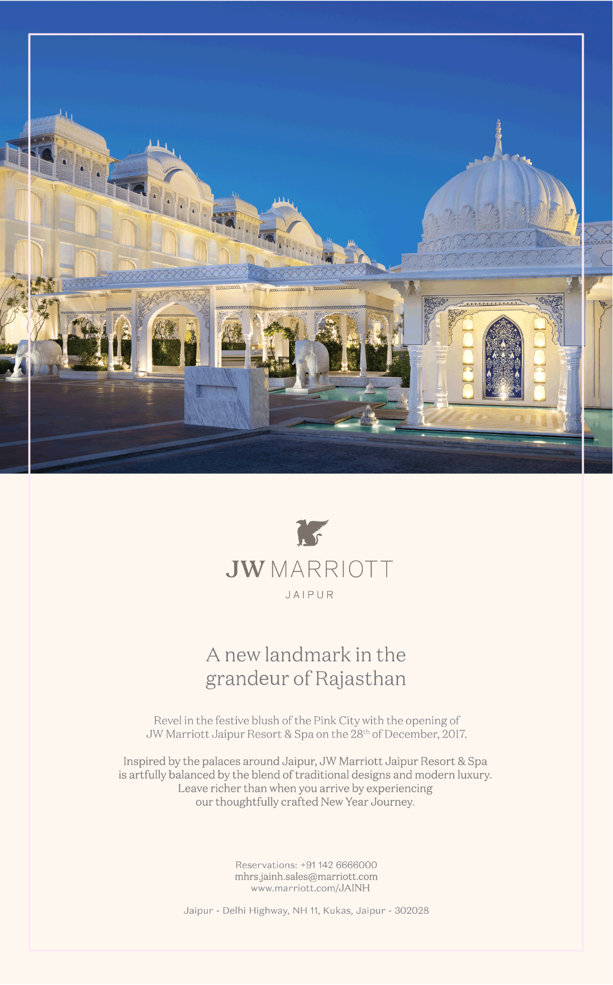

This ad on New Year Carnival does not mention pricing.

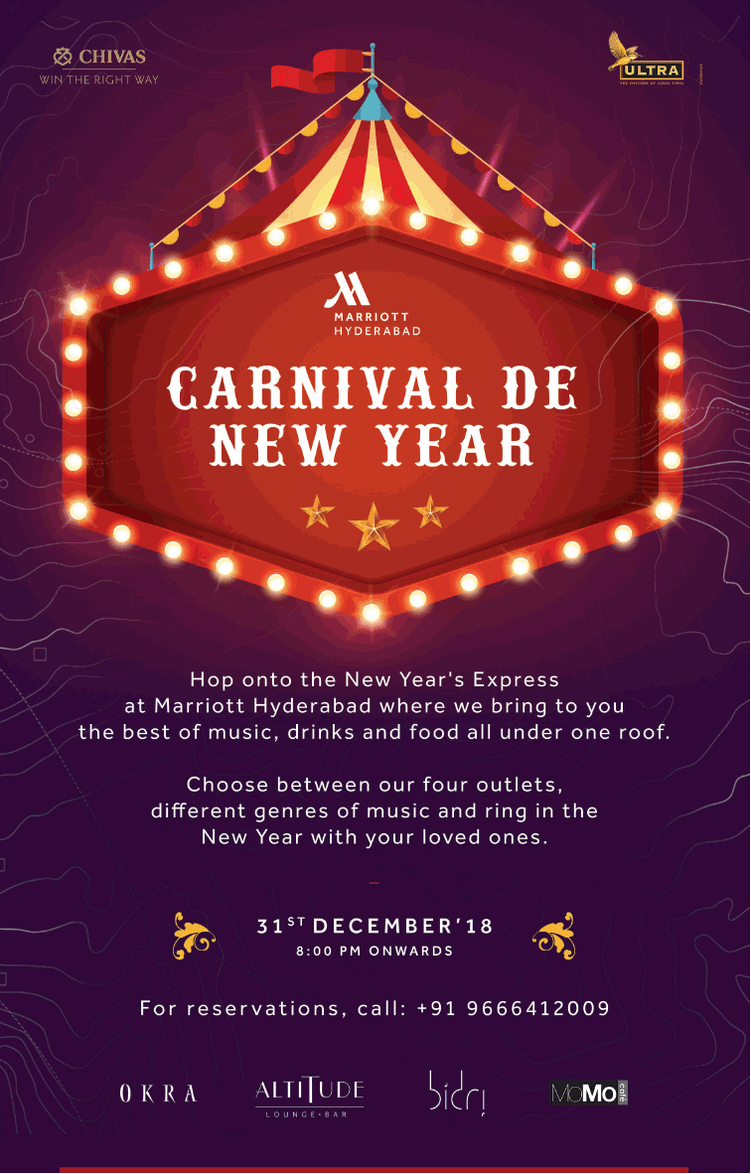

Their Google Ad emphasizes Experiences and Brands and does not explicitly mention rates.

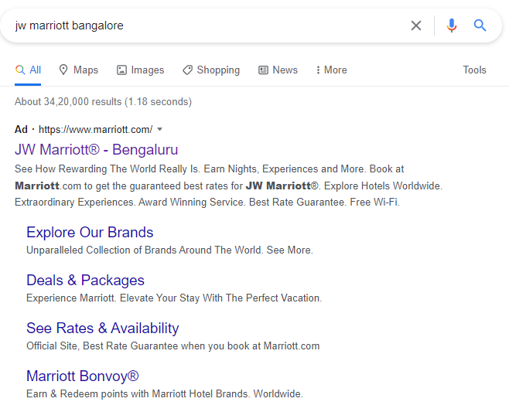

1. **Communicate to those whom you are not targeting.**

Marriott partnered with Snapchat influencers to make Snapisodes - that mimic TV travel documentaries. In these Snapisodes, the influencers showcased Marriott’s new and luxury properties.

It reaches out of Snapchat to YouTube, Facebook sharing, and other channels to capture the attention of other demographics. The content is good and barely resembles advertising.

Marriott wanted the series to be like TV, while at the same time being user-generated content from influencers with large social communities. The idea was to bring brand awareness to a generation that doesn’t have a clear picture of Marriott’s brand.

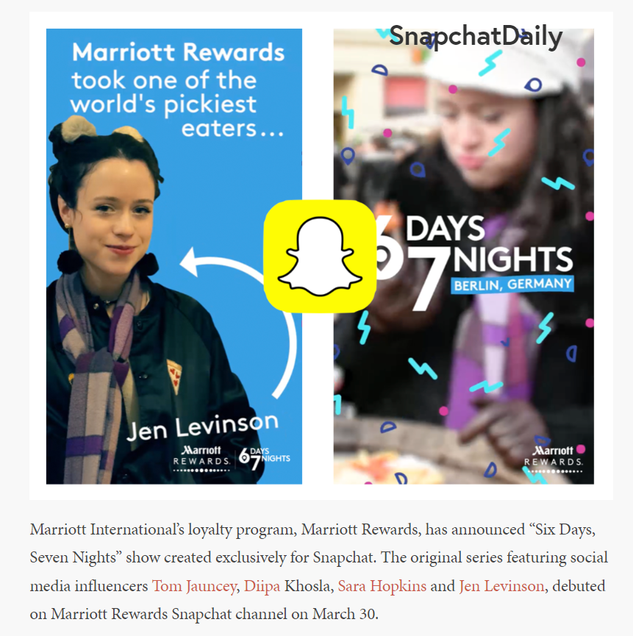

1. **The presumed price should always seem higher than the actual price.**
2. **Luxury sets the price; price does not set luxury.**

It can be seen from their website that the content speaks about the luxurious experience that awaits the customer.

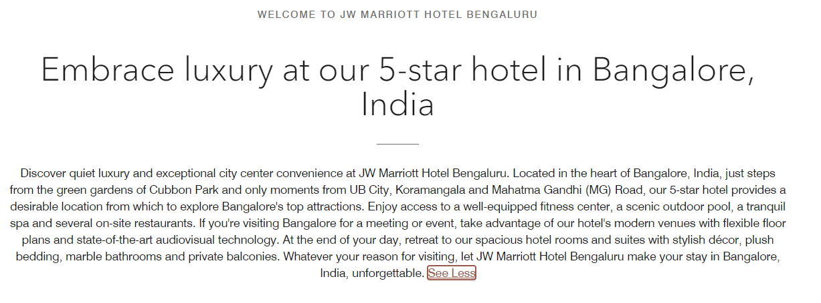

1. **Raise your prices as time goes on, in order to increase demand.**
2. **Keep raising the average price of the product range.**
3. **Keep stars out of your advertising**

None of JW Marriott ads showcase any celebrity. From Ms. Pearl’s response, it is seen that JW Marriott does not make exceptions for Celebrities.

1. **Cultivate closeness to the arts for the initiate.**

JW Marriott Bengaluru partnered with Asian Art House and launched art showcase event called Horizons.

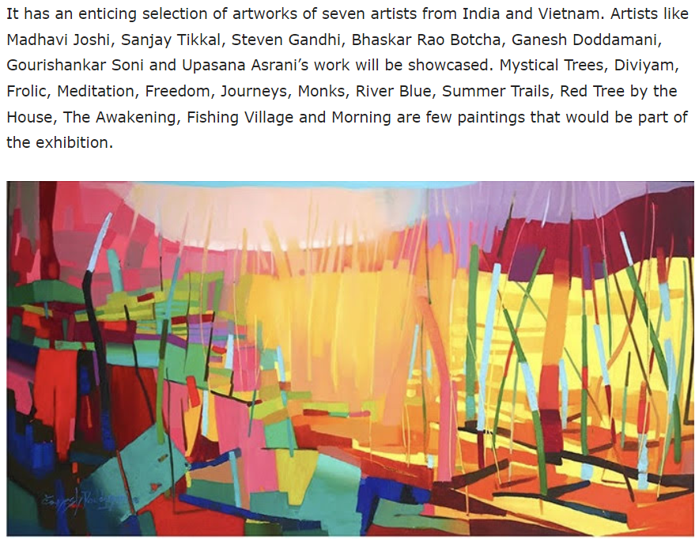

It conducted another event called “Summer Hues” in 2018 showcasing Vietnamese and Indian Art.



1. **Don’t pander to your customers’ wishes.**
2. **Don’t respond to rising demand.**
3. **Do not sell.**

All the promotions of JW Marriott focus on highlighting the luxurious experience and do not persuade to sell.

They try to elevate the experience every time by increasing their value proposition, their brand image and try to attract customers rather than forceful selling.

1. **Do not relocate your factories.**
2. **Do not hire consultants.**
3. **Do not test.**
4. **Do not look for consensus.**
5. **Do not look after group synergies.**
6. **Do not look for cost reduction.**
7. **Do not sell openly on the Internet.**

From Ms. Pearl’s response it is seen that Marriott does not endorse paid influencer content.

1. **Keep Non-enthusiasts out.**

The Bonvoy Membership offers and benefits are exclusive only to customers of Marriott hotels. Below Ads show various campaigns targeted and offered exclusively to Bonvoy members.

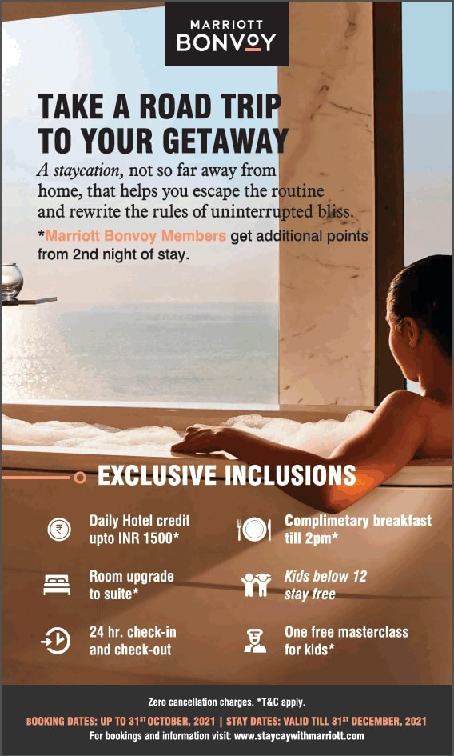

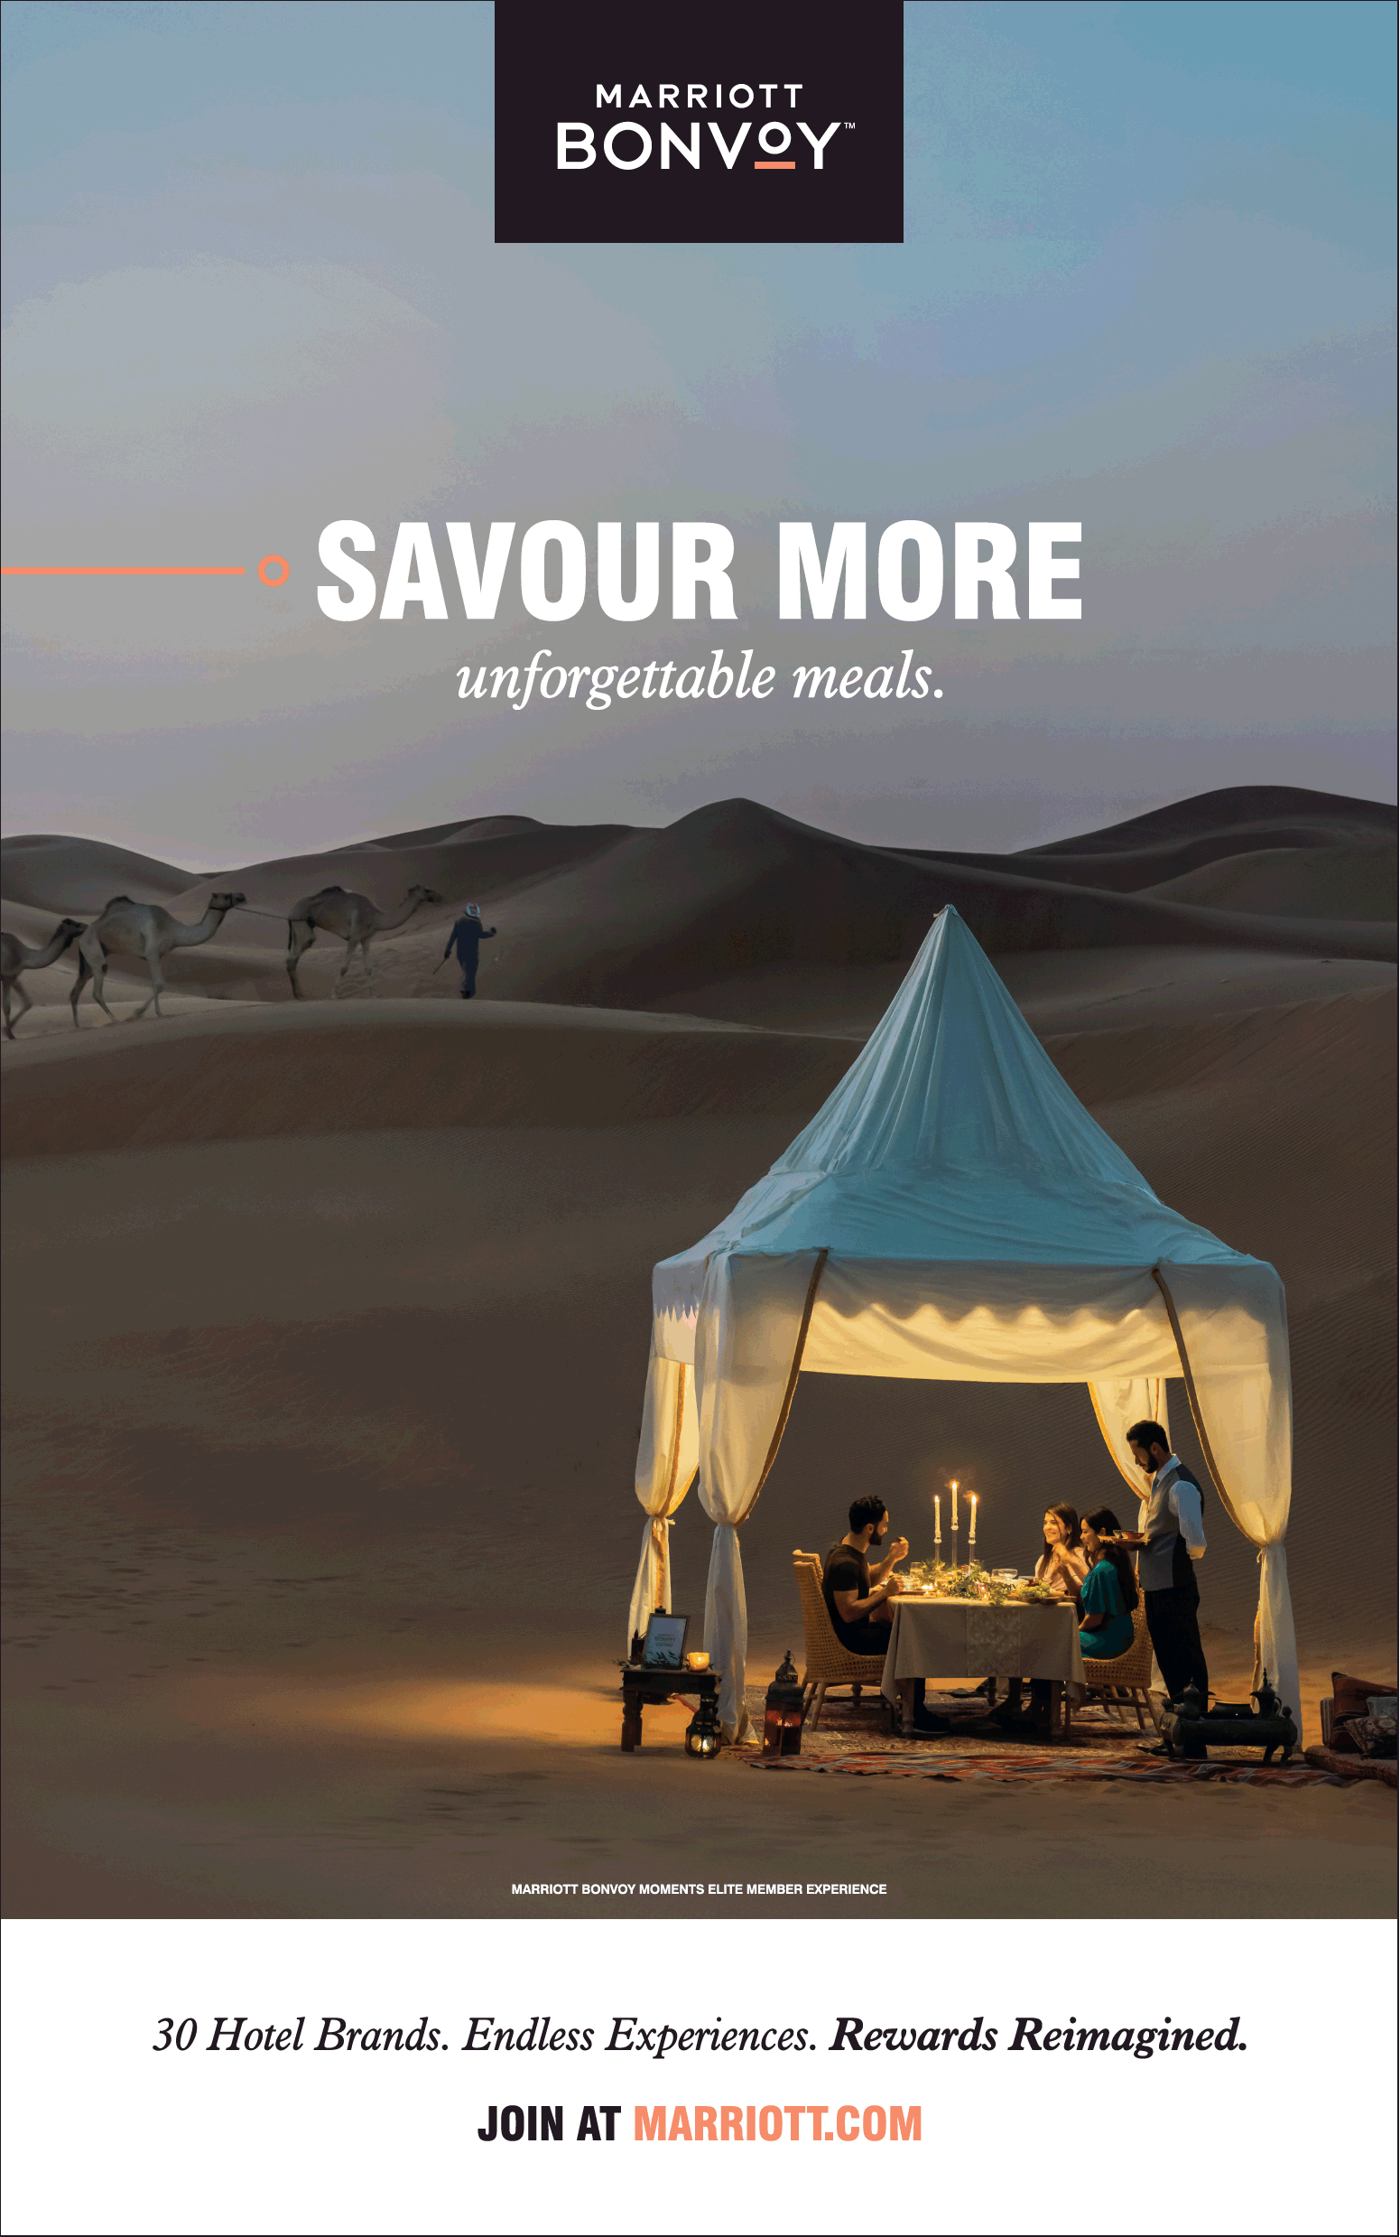

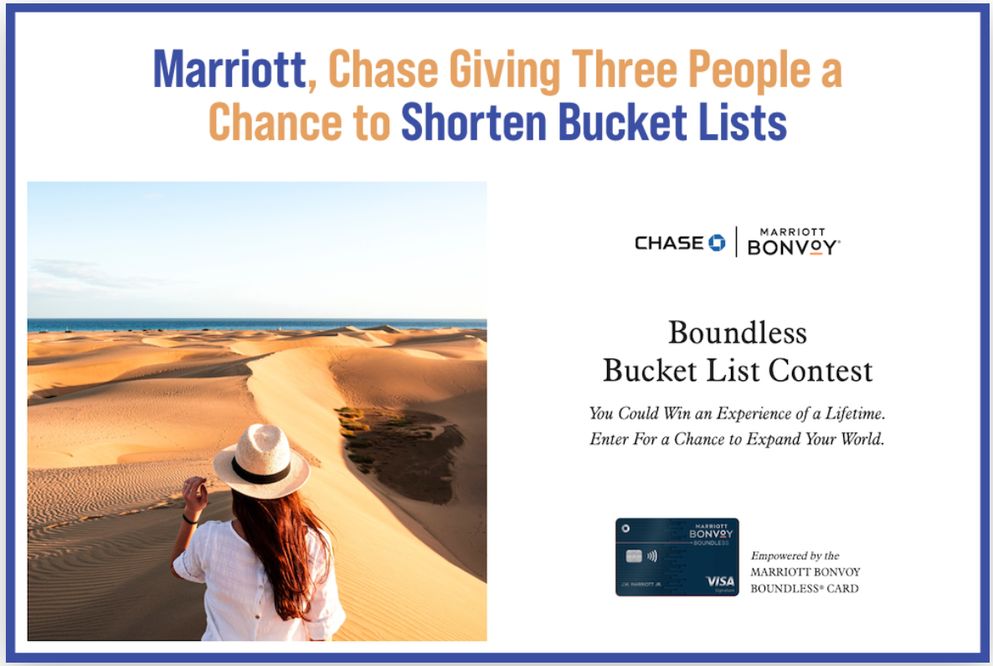

**d) Customer Reviews**

**Customer 1**

**Q1. Are you a regular customer of JW Marriott?**

No. But I have stayed in other Marriott hotels.

**Q2. Are you a business traveler or holidayer or party/wedding customer?**

I travel mostly for business.

**Q3. Are you from Bangalore or other location?**

I am from Bangalore. My corporate has booked the hotel for me for a business meet.

**Q4. Are you satisfied with the services offered by JW Marriott?**

Yes.

**Q5. Is there anything that is unique about JW Marriott which you did not find in other luxury hotels?**

Nothing as such. One noticeable thing about this resort is that its room size is bigger than other resorts. Staffs are courteous and better than Taj. Services are at par with ITC. Resort is new, so very hygienic. The Golf Course and Lake are unique attractions.

**Q6. What are the amenities you make use of?**

Gym. I hardly use other amenities

**Q7 Are you aware of the secret spot?**

Yes. But I do not read or meditate much, so didn’t.

**Q8. Do you have any complaints about JW Marriott?**

No. It’s one of those peaceful hotels which is ideal for vacationers. Their Convention Center is awesome.

**Q9. How would you rate JW Marriott against its competitors ITC, Taj, Leela Palace, Four Seasons on a scale of 1 to 5?**

I would rate JW Marriott - 4.5/5, Taj – 4.3/5, ITC – 4.6/5, Leela – 4.5/5. Never been to Four Seasons, so cannot rate.

**Q10. Would you recommend JW Marriott to your friends, family/relatives?**

Yes.

**Q11. Is there any improvements you want to suggest regarding the services?**

Nothing as such.

**Customer 2**

**Q1. Are you a regular customer of JW Marriott?**

No. This is my first time with JW Marriott.

**Q2. Are you a business traveler or holidayer or party/wedding customer?**

This stay is for celebrating my child’s birthday. So it’s a trip with my family.

**Q3. Are you from Bangalore or other location?**

I am from Bangalore.

**Q4. Are you satisfied with the services offered by JW Marriott?**

Yes. Very much.

**Q5. Is there anything that is unique about JW Marriott which you did not find in other luxury hotels?**

My kids loved the stay so much. The staff are courteous and made his day special with complimentary cake, balloons and candies. Never been to other hotels. So cannot compare.

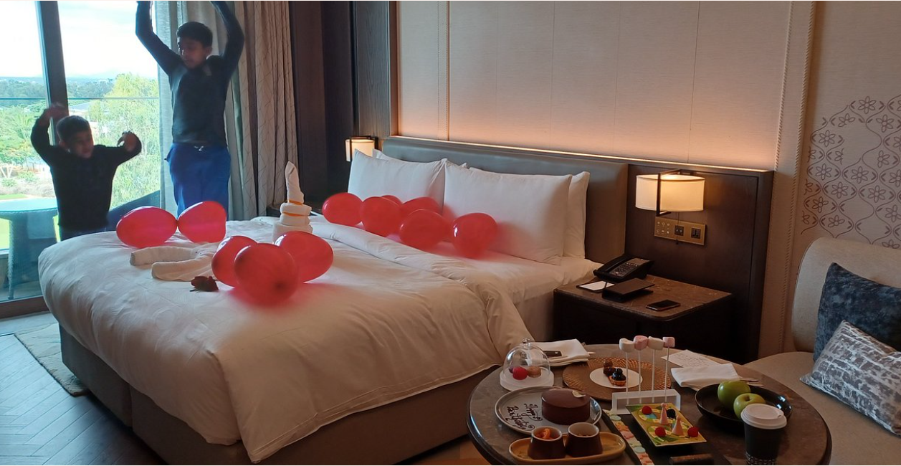

**Q6. What are the amenities you make use of?**

My kids loved the cycling, game room and swimming.

**Q7 Are you aware of the secret spot?**

Yes. We did use them.

**Q8. Do you have any complaints about JW Marriott?**

No. We enjoyed every bit of our stay.

**Q9. How would you rate JW Marriott against its competitors ITC, Taj, Leela Palace, Four Seasons on a scale of 1 to 5?**

I would rate JW Marriott - 4.7/5 and ITC Gardenia – 4.8/5.

Never been to other hotels.

**Q10. Would you recommend JW Marriott to your friends, family/relatives?**

Yes. Very much.

**Q11. Is there any improvements you want to suggest regarding the services?**

No. The service was fine.

**Customer 3**

**Q1. Are you a regular customer of JW Marriott?**

Yes. I am a platinum Bonvoy member.

**Q2. Are you a business traveler or holidayer or party/wedding customer?**

I stay mostly for business reasons.

**Q3. Are you from Bangalore or other location?**

I am from Bangalore.

**Q4. Are you satisfied with the services offered by JW Marriott?**

JW Marriott Yes. Disappointed with Golfshire Resort.

**Q5. Why were you disappointed?**

Food in club lounge was served cold.  
They don’t have any spread of spirits.  
Even Courtyard will have a better lounge for platinum members.

**Q6. What are the amenities you make use of, generally?**

The Lounge and Bar mostly. Spa occasionally.

**Q7 Are you aware of the secret spot?**

Yes. But I hardly spent my time around the property.

**Q8. How would you rate JW Marriott against its competitors ITC, Taj, Leela Palace, Four Seasons on a scale of 1 to 5?**

I like Marriott’s brands. Most of my stays are with them. I would rate JW Marriott in the city - 4.6/5.

Four Seasons is a tough competition to JW Marriott and scores in international class. ITC, Leela and Taj are more Indian.

**Q10. Would you recommend JW Marriott to your friends, family/relatives?**

Yes.

**Q11. Is there any improvements you want to suggest regarding the services?**

Yeah. Sometimes they falter on service standards to Elite members. They should address this, else they will lose out to Four Seasons.

**5.**  **Conclusion**

We understand from the primary and secondary research information that JW Marriott & Marriott consortium exhibit luxury brand behaviour both in physical and online platforms. We understood the STP of Marriott brand, 8 Ps of Luxury Marketing Mix etc. We also understood how they follow the anti-laws of marketing and how the brand preserves its exclusivity and rarity.

**6.**  **References:**

<https://ivypanda.com/essays/marriott-hotels-resorts-market-segmentation-analysis/>

<https://studycorgi.com/marriotts-market-segmentation-and-positioning/>

<https://www.notesmatic.com/marriott-international-marketing-mix/>

<https://iide.co/case-studies/marketing-strategy-marriott-international/>

<https://www.mbaskool.com/marketing-mix/services/17317-marriott.html>

<https://idoc.pub/download/j-w-marriott-report-on-7ps-in-marketing-546gy1wk57n8>

<https://mobile.twitter.com/JWMarriottJuhu/status/1491667689512714241>

<https://www.magrinopr.com/pr-case-studies/digital-social-public-relations/jw-marriott-nashville/>

<https://www.comparably.com/companies/marriott/mission>

<https://www.mordorintelligence.com/industry-reports/india-luxury-hotel-market>

<https://luxuryhotel.guru/bangalore-city/>

<https://www.maximizemarketresearch.com/market-report/india-luxury-hotel-market/127656/#:~:text=India%20Luxury%20Hotel%20Market%20was,in%202027>.

<https://www.linkedin.com/pulse/24-anti-laws-marketing-must-read-luxury-strategy-article-rahul-dutta/>

<https://seekingalpha.com/article/4349472-marriott-prices-dont-reflect-long-road-to-recovery>

<https://www.verifiedmarketresearch.com/product/global-luxury-hotel-market-size-and-forecast-to-2025/#:~:text=Luxury%20Hotel%20Market%20size%20was,4.1%25%20from%202020%20to%202027>.

<https://www.siteminder.com/r/global-distribution-system/>